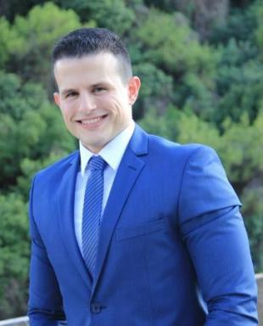 Gerald MATAR

Présentation

Publications

Article dans une revue (4)

Modelling the benefits of urine source separation scenarios on wastewater treatment plants within an urban water basin
Gerald Matar,Mathilde Besson,Jennifer Mas,Sam Azimi,Vincent Rocheret al.
Water Science and Technology, 2022, 86 (3), pp.482-495. ⟨10.2166/wst.2022.208⟩
Article dans une revue
hal-03839842v1
Membrane biofilm communities in full-scale membrane bioreactors are not randomly assembled and consist of a core microbiome
Gerald Matar,Samik Bagchi,Kai Zhang,Daniel Oerther,Pascal Saikaly
Water Research, 2017, 123, pp.124-133. ⟨10.1016/j.watres.2017.06.052⟩
Article dans une revue
hal-02321439v1
Temporal changes in extracellular polymeric substances on hydrophobic and hydrophilic membrane surfaces in a submerged membrane bioreactor
Gerald Matar,Graciela Gonzalez-Gil,Husnul Maab,Suzana Nunes,Pierre Le-Clechet al.
Water Research, 2016, 95, pp.27-38. ⟨10.1016/j.watres.2016.02.064⟩
Article dans une revue
hal-02322089v1
A Microfiltration Polymer-Based Hollow-Fiber Cathode as a Promising Advanced Material for Simultaneous Recovery of Energy and Water
Krishna Katuri,Narasimha Murthy Srivatsa Bettahalli,Xianbin Wang,Gerald Matar,Stefan Chiscaet al.
Advanced Materials, 2016, 28 (43), pp.9504-9511. ⟨10.1002/adma.201603074⟩
Article dans une revue
hal-02321875v1

Communication dans un congrès (1)

A modelling methodology to predict the advantages of urine source separation in Paris
Gerald Matar,Mathilde Besson,Sam Azimi,Vincent Rocher,Kai M. Udertet al.
10th IWA Symposium on Modelling and Integrated Assessment. Watermatex., Sep 2019, Copenhagen, Denmark
Communication dans un congrès
hal-04933917v1

Thèse (1)

Characterization of Membrane Foulants in Full-scale and Lab-scale Membrane Bioreactors for Wastewater Treatment and Reuse.
Gerald Matar,Gerald Kamil Matar
Environmental Sciences. King Abdullah University of Science and Technology, 2015. English. ⟨NNT : ⟩
Thèse
tel-02323062v1

