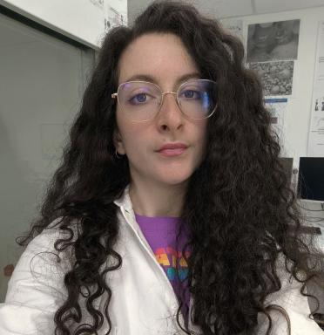 Greta Ugolotti

Présentation

Greta is a conservator and a Ph.D in materials Engineering and her last work experience was a Postdoctorate in Materials Science for Conservation of Cultural Heritage in Paris, with CNRS (Dim Pamir), working between C2RMF and Université Gustave Eiffel, under Ann Bourges supervision with a project for the desalination of sensitive objects like archaeological paintings (from the Louvre and ArlesArcheological Museum) with agar gels. She was awarded the Ph.D degree in Civil, Chemical, Environmental, and Materials Engineering (DICAMUNIBO) in June 2024 with a thesis about phosphate treatments for Cultural Heritage on challenging substrates (such as salt-contaminated or pigmented ones) under Professor Enrico Sassoni's supervision. In 2023 she spent 6 months in Los Angeles betweenUCLA and Getty Villa, working on fresco mock-ups, under Professor Dr. Ioanna Kakoulli’s supervision for the Ph.D project. She also assisted prof. Alberto Fregni for his teaching course during her Ph.D. In 2020 Greta graduated with honors in Conservation and Restoration of Cultural Heritage in the PFP1 profile (stones, frescoes and mosaics) at the UNIBO (Ravenna), with a thesis about sustainable and innovative products for marble conservation (enzymatic gels, essential oils for bio-cleaning, and DAP for consolidation) and she is enrolled in the Italian National Register of Conservators.

Publications

Rapport (1)

DIM PAMIR Patrimoines matériels -innovation, expérimentation et résilience Charte de réutilisation des données du projet DEGEL
Ann Bourges,Emmanuel Keita,Greta Ugolotti
DIM pamir. 2025, pp.IDF-DIM-PAMIR-2022-2-008
Rapport
hal-05284626v1

