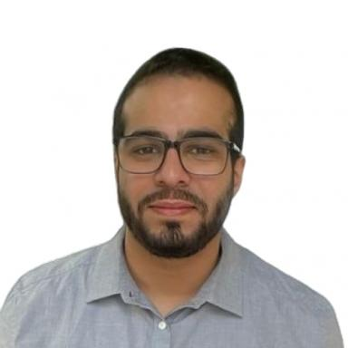 Hadi ABDINE

Identifiants chercheurs

- IdHAL :
hadiabdine
- ORCID :
0009-0001-3944-4747
- arXiv :
abdine_h_1

Présentation

I am Hadi Abdine, an engineer at MBZUAI France lab. I hold a Ph.D. in computer science, data and AI from Institut Polytechnique de Paris. My studies were done at LIX-École Polytechnique with the DaSciM team under the supervision of Prof. Michalis Vazirgiannis. My current research work focuses on natural language processing, pretrained language models and their application. Before joining LIX as a Ph.D. candidate, I graduated with a Master degree in data science from Institut Polytechnique de Paris, an engineering degree in data science from Telecom Paris and an engineering degree in computer science and telecommunication from the Lebanese university, Faculty of Engineering 1.
Dedicated to the field of Natural Language Processing (NLP) and the advancements facilitated by large language models, I am deeply passionate about the intersection of technology and linguistics. My research focuses on diverse NLP applications using transformer-based language models and LLMs. This envolves semantic, political, legal and bioinformatical (e.g. proteins function generation in free text using their 3D structures and amino acid sequences) applications.

Publications

Article dans une revue (1)

Word sense induction with agglomerative clustering and mutual information maximization
Hadi Abdine,Moussa Kamal Eddine,Davide Buscaldi,Michalis Vazirgiannis
AI Open, 2023, 4, pp.193-201. ⟨10.1016/j.aiopen.2023.12.001⟩
Article dans une revue
hal-04445537v1

Communication dans un congrès (5)

Prot2Text: Multimodal Protein's Function Generation with GNNs and Transformers
Hadi Abdine,Michail Chatzianastasis,Costas Bouyioukos,Michalis Vazirgiannis
38th Annual AAAI Conference on Artificial Intelligence (AAAI-24), Feb 2024, Vancouver, Canada. pp.10757-10765, ⟨10.1609/aaai.v38i10.28948⟩
Communication dans un congrès
hal-04555695v1
Evaluation of Word Embeddings from Large-Scale French Web Content
Hadi Abdine,Christos Xypolopoulos,Moussa Kamal Eddine,Michalis Vazirgiannis
Conférence Nationale en Intelligence Artificielle 2022 (CNIA 2022), Jun 2022, Saint-etienne, France
Communication dans un congrès
hal-04454559v1
Political Communities on Twitter: Case Study of the 2022 French Presidential Election
Hadi Abdine,Yanzhu Guo,Virgile Rennard,Michalis Vazirgiannis
First Workshop on Natural Language Processing for Political Sciences (politicalnlp2022) co-located with LREC 2022, Jun 2022, Marseille, France. pp.62-71
Communication dans un congrès
hal-04445532v1
Évaluation et Production de Plongements de Mots à Partir de Contenus Web Français à Grande Échelle
H Abdine,C Xypolopoulos,M Kamal Eddine,M Vazirgiannis
Conférence Nationale en Intelligence Artificielle 2022 (CNIA 2022), Jun 2022, Saint-Etienne, France
Communication dans un congrès
hal-03866286v1
JuriBERT: A Masked-Language Model Adaptation for French Legal Text
Stella Douka,Hadi Abdine,Michalis Vazirgiannis,Rajaa El Hamdani,David Restrepo Amariles
Natural Legal Language Processing Workshop 2021, Nov 2021, Punta Cana, Dominican Republic. pp.95-101, ⟨10.18653/v1/2021.nllp-1.9⟩
Communication dans un congrès
hal-04445520v1

