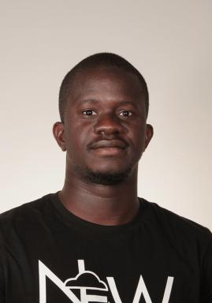 Hafiz TIOMOKO ALI

Identifiants chercheurs

- IdHAL : hafiz-tiomoko-ali
- ResearcherID : G-9812-2016

Présentation

Publications

Article dans une revue (2)

Improved spectral community detection in large heterogeneous networks
Hafiz Tiomoko Ali,Romain Couillet
Journal of Machine Learning Research, 2018, 18 (10), pp.1-49
Article dans une revue
hal-01957623v1
The asymptotic performance of linear echo state neural networks
Romain Couillet,Gilles Wainrib,Harry Sevi,Hafiz Tiomoko Ali
Journal of Machine Learning Research, 2016, 17 (178), pp.1-35
Article dans une revue
hal-01322809v1

Communication dans un congrès (6)

Random matrix-improved kernels for large dimensional spectral clustering
Hafiz Tiomoko Ali,Abla Kammoun,Romain Couillet
2018 IEEE Statistical Signal Processing Workshop (SSP), Jun 2018, Freiburg, Germany. ⟨10.1109/ssp.2018.8450705⟩
Communication dans un congrès
hal-01812009v1
Random matrix asymptotics of inner product kernel spectral clustering
Hafiz Tiomoko Ali,Abla Kammoun,Romain Couillet
IEEE International Conference on Acoustics, Speech, and Signal Processing (ICASSP 2018), Apr 2018, Calgary, Canada. ⟨10.1109/icassp.2018.8462052⟩
Communication dans un congrès
hal-01812005v1
A Random Matrix Approach to Echo-State Neural Networks
Romain Couillet,Gilles Wainrib,Hafiz Tiomoko Ali,Harry Sevi
International Conference on Machine Learning (ICML 2016), Jun 2016, New York, United States
Communication dans un congrès
hal-01812026v1
Random matrix improved community detection in heterogeneous networks
Hafiz Tiomoko Ali,Romain Couillet
50th Asilomar Conference on Signals, Systems and Computers, Nov 2016, Pacific Grove, United States. ⟨10.1109/acssc.2016.7869603⟩
Communication dans un congrès
hal-01812036v1
Training Performance of Echo State Neural Networks
Romain Couillet,Gilles Wainrib,Harry Sevi,Hafiz Tiomoko Ali
IEEE Statistical Signal Processing Workshop 2016 (SSP'16), Palma de Majorca, Spain, Jun 2016, Palma de Majorca, Spain
Communication dans un congrès
hal-01633450v2
Performance Analysis of spectral community detection in realistic graph models
Hafiz Tiomoko Ali,Romain Couillet
IEEE International Conference on Acoustics, Speech and Signal Processing (ICASSP'16), Shanghai, China, Mar 2016, Shanguai, China. ⟨10.1109/icassp.2016.7472538⟩
Communication dans un congrès
hal-01322797v1

