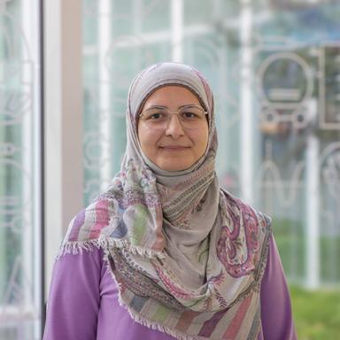 Hawraa BECHER Doctorante en Génie Électrique Nantes Université, Laboratoire IREENA UR 4642

Publications

Communication dans un congrès (2)

Sensitive Device for Probing and Recognition of Obstacles in a Natural Environment
Hawraa Becher,Lama Al Bassit,Bastien Laurent,Hubert Villeneuve,Guillaume Jeanneau
Agritech Day, Axema, Oct 2023, Rennes (FR), France. pp.66-75
Communication dans un congrès
hal-04248671v1
Sensitive Device for Probing and Recognition of Obstacles in a Natural Environment
Hawraa Becher,Lama Al Bassit,Bastien Laurent,Hubert Villeneuve,Guillaume Jeanneau
Agritech Day, Axema, Oct 2023, Rennes, France
Communication dans un congrès
hal-04937916v1

