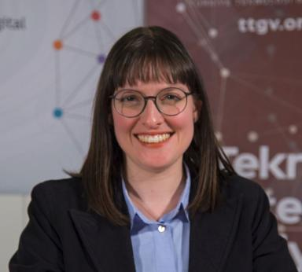 Hazal Baytok

Publications

Proceedings/Recueil des communications (1)

Digital Platform Participation: Recreational and Platform-Based Motivations in Citizen Science
Hazal Baytok
17th Mediterranean Conference on Information Systems, Oct 2025, Nantes, France. https://uncloud.univ-nantes.fr/index.php/s/inn8bMzCDr9Dfxi?openfile=true, 2025
Proceedings/Recueil des communications
hal-05391980v1

Thèse (1)

Participation in Citizen Science : Motivational and Contextual Factors
Hazal Baytok
Business administration. Université Paris-Saclay, 2024. English. ⟨NNT : 2024UPASI001⟩
Thèse
tel-04661836v1

Communication dans un congrès (5)

Participation motivations and platform governance in citizen science platforms
Hazal Baytok,Müge Özman,Nicolas Jullien
ECSA Conference 2022. Citizen science for planetary health, European Citizen Science Association; Museum für naturkunde Berlin, Oct 2022, Berlin, Germany
Communication dans un congrès
hal-05392008v1
The feedback loop between the online citizen science platforms and their participants: an empirical study of how institutions and motivations are shaped
Hazal Baytok,Nicolas Jullien,Müge Özman
Eu-SPRI 2022 : European Forum for Studies of Policies for Research and Innovation, Jun 2022, Utrecht, Netherlands. pp.171
Communication dans un congrès
hal-04122230v1
Institutional Analysis and Development (IAD) framework applied: ornithology citizen science cases from Turkey
Hazal Baytok,Müge Özman,Nicolas Jullien
IASC 2021 General Conference, International Association for the Study of the Commons; Arizona State University; The University of Arizona, Oct 2021, Online (Arizona-Worldwide), United States
Communication dans un congrès
hal-04177524v1
Motivation for participation in citizen sience: a bibliometric analysis
Hazal Baytok,Müge Özman,Nicolas Jullien
4S 2021 : Annual Meeting of the Society for Social Studies of Science, Oct 2021, Online (Toronto and Worldwide), Canada
Communication dans un congrès
hal-04177510v1
Knowledge generation, legitimacy and social imaginaries in citizen science: ornithology cases from Turkey
Hazal Baytok,Müge Özman,Nicolas Jullien
4S 2021 : Annual Meeting of the Society for Social Studies of Science, Oct 2021, Online (Toronto and Worldwide), Canada
Communication dans un congrès
hal-04177518v1

