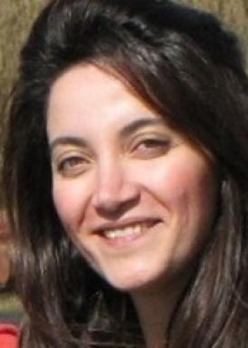 Hedyeh Mobahi

Identifiants chercheurs

- IdHAL : hedyeh-mobahi
- cv.identifier.google scholar : https://scholar.google.fr/citations?user=ouWUhaYAAAAJ

Publications

Communication dans un congrès (1)

Guiding Supervised Learning by Bio-Ontologies in Medical Data Analysis
Janusz Wojtusiak,Hua Min,Eman Elashkar,Hedyeh Mobahi
4th IFIP International Workshop on Artificial Intelligence for Knowledge Management (AI4KM), Jul 2016, New York, NY, United States. pp.1-18, ⟨10.1007/978-3-319-92928-6_1⟩
Communication dans un congrès
hal-01950012v1

