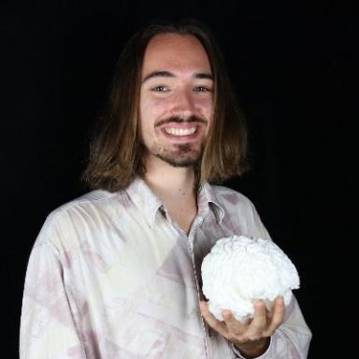 Hugo Chateau-Laurent Doctorant au Centre Inria de l'Université de Bordeaux

Identifiants chercheurs

- IdHAL : hugo-chateau-laurent
- ORCID : 0000-0002-2891-0503

Publications

Communication dans un congrès (8)

ReMi: A Random Recurrent Neural Network Approach to Music Production
Hugo Chateau-Laurent,Tara Vanhatalo,Wei-Tung Pan,Xavier Hinaut
ICMC 2025 - International Computer Music Conference, Jun 2025, Boston (MA), United States
Communication dans un congrès
hal-05393077v1
Contextual Control of Hopfield Networks in a Hippocampal Model
Hugo Chateau-Laurent,Frédéric Alexandre
COGSCI 2024 - 46th Annual Conference of the Cognitive Science Society, Jul 2024, Rotterdam, Netherlands
Communication dans un congrès
hal-04639128v1
Relating Hopfield Networks to Episodic Control
Hugo Chateau-Laurent,Frédéric Alexandre
NeurIPS 2024 - 38th Conference on Neural Information Processing Systems, Dec 2024, Vancouver, Canada
Communication dans un congrès
hal-04850730v1
Sample my Canary
Hugo Chateau-Laurent,Xavier Hinaut
2023 Drôles d'Objets - Un nouvel art de faire, https://drolesdobjets23.sciencesconf.org/, May 2023, Nancy, France
Communication dans un congrès
hal-04154799v1
The Opportunistic PFC: Downstream Modulation of a Hippocampus-inspired Network is Optimal for Contextual Memory Recall
Hugo Chateau-Laurent,Frédéric Alexandre
36th Conference on Neural Information Processing System, Dec 2022, New Orleans, United States
Communication dans un congrès
hal-03885715v1
Augmenting Machine Learning with Flexible Episodic Memory
Hugo Chateau-Laurent,Frédéric Alexandre
13th International Joint Conference on Computational Intelligence, Oct 2021, Valletta, Malta
Communication dans un congrès
hal-03359384v1
Towards a Computational Cognitive Neuroscience Model of Creativity
Hugo Chateau-Laurent,Frédéric Alexandre
IEEE ICCI*CC'21 - 20th IEEE International Conference on Cognitive Informatics and Cognitive Computing, Oct 2021, Banff, Canada
Communication dans un congrès
hal-03359407v1
Ontology as neuronal-space manifold: Towards symbolic and numerical artificial embedding
Chloé Mercier,Hugo Chateau-Laurent,Frédéric Alexandre,Thierry Viéville
KRHCAI 2021 Workshop on Knowledge Representation for Hybrid & Compositional AI @ KR2021, Nov 2021, Hanoi, Vietnam
Communication dans un congrès
hal-03360307v3

Poster de conférence (2)

Modelling prefrontal-hippocampal interactions for contextual controlled learning using artificial neural networks
Hugo Chateau-Laurent,Frédéric Alexandre
FENS Forum 2022, Jul 2022, Paris, France
Poster de conférence
hal-03941366v1
Modèle neuronal unifié du traitement conscient et inconscient
Hugo Chateau-Laurent,Frédéric Alexandre,Chris Eliasmith,Serge Thill
Colloque des Jeunes Chercheur.se.s en Sciences Cognitives 2021, Mar 2021, Online, France
Poster de conférence
hal-03169486v1

Pré-publication, Document de travail (1)

Learning to Chain Operations by Routing Information Through a Global Workspace
Hugo Chateau-Laurent,Rufin VanRullen
2025
Pré-publication, Document de travail
hal-05373577v1

