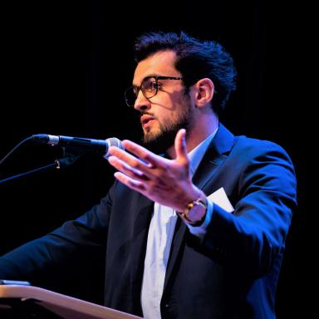 Hugo d'Assenza-David PhD Candidate

Identifiants chercheurs

- IdHAL : hugo-dassenzadavid
- ORCID : 0000-0001-9623-6349

Présentation

I am a French PhD candidate in comparative politics at Sciences Po (CERI / CSO), working at the intersection of urban studies, public policy analysis, and a critical sociology of risk.
My current research compares the development of material flow accounting systems and their integration into territorial planning strategies in the metropolitan regions of Paris and Amsterdam. Drawing on policy instruments as an analytical entry point, my work examines how these accounting tools contribute to the identification, framing, and governance of what I conceptualize as 'metabolic risk', namely the incorporation of biophysical vulnerabilities into territorial governance.
More broadly, my research engages with transformations of the State, and policy change dynamics. In my work, I study the reshuffling of political and territorial power in a context of mounting ecological, social, and geopolitical risks. My research has been evaluated through peer review and has been published, or is forthcoming, in a range of academic journals including Cities, Territory, Politics, Governance, and Ecological Economics. In addition, some of my book chapters have been published by established academic presses, including Sciences Po Press and Mines Paris Press.
*PhD Title: **Planning the city from its material flows, or the governance of the biophysical limits of power. Accounting for and constructing metabolic risk in the urban regions of Paris and Amsterdam.
I have undertaken research stays at the London School of Economics and Political Science (Department of Government) and at the Universität für Bodenkultur Wien (Institute of Social Ecology). I have also been an associate researcher at the University of Glasgow (Urban Big Data Centre), as well as a prospective research officer for the Plan Urbanisme Construction Architecture (PUCA) and for the Deutsche Gesellschaft für Internationale Zusammenarbeit (GIZ).

Publications

Article dans une revue (4)

Casting doubts on the growth machine? Doughnut economics, an ambiguous innovation in Amsterdam governance
Hugo D’assenza-David
Territory, Politics, Governance, 2026, 17 p. ⟨10.1080/21622671.2025.2606157⟩
Article dans une revue
hal-05473812v1
Bourdieu in the city: Challenging urban theory, by Loïc Wacquant, Cambridge, Polity Press, 2023
Hugo d'Assenza-David
Journal of Urban Affairs, 2025, 47 (3), pp.1109-1111. ⟨10.1080/07352166.2023.2285688⟩
Article dans une revue
hal-05490380v1
Une feuille de route pour une planification territoriale des Trentes Turbulentes. Sur les chantiers de l’adaptation de nos territoires
Hugo d'Assenza-David
Pouvoirs Locaux : les cahiers de la décentralisation / Institut de la décentralisation, 2024, 126, pp.103-107
Article dans une revue (compte-rendu de lecture)
hal-04940986v1
Eco-neighborhoods and the question of locational advantage: A socio-spatial analysis of French ‘ÉcoQuartiers’
Simon Joss,Hugo d'Assenza-David,Luis Serra
Cities, 2022, 126, pp.103643. ⟨10.1016/j.cities.2022.103643⟩
Article dans une revue
hal-05490382v1

Ouvrages (1)

Bruxelles : une ville productive et résidentielle
Hugo d'Assenza-David
Editions PUCA. , 2021, 9782111382008
Ouvrages
hal-03340458v2

Chapitre d'ouvrage (1)

Territoire
Hugo d'Assenza-David,Alice Mazeaud
Dictionnaire d'écologie politique, Presses de Sciences Po, pp.537-543, 2025, 9782724644906. ⟨10.3917/scpo.estev.2025.01.0537⟩
Chapitre d'ouvrage
hal-05490402v1

Pré-publication, Document de travail (1)

Casting Doubts on the Growth Machine? Doughnut Economics, an Ambiguous Innovation in Amsterdam Governance
Hugo d'Assenza-David
2026
Pré-publication, Document de travail
hal-05490367v1

Rapport (1)

Shifting circular: urban infrastructure and policy changes towards renewed territorial metabolisms
Hugo d'Assenza-David
Deutsche Gesellschaft für Internationale Zusammenarbeit (GIZ). 2023
Rapport
hal-04267024v1

