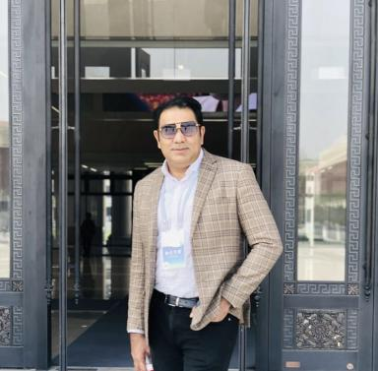 Inam ul Haq

Présentation

Publications

Article dans une revue (4)

When do challenge‐hindrance stressors differentially effect employees' ability to meet work deadlines?
Muhammad Umer Azeem,Iqbal Mehmood,Inam Ul Haq,Elda Nasho Ah-Pine
Canadian Journal of Administrative Sciences - Revue Canadienne des Sciences de l'Administration, 2024, ⟨10.1002/cjas.1769⟩
Article dans une revue
hal-04752420v1
Effects of perceived organisational politics and effort–reward imbalance on work outcomes – the moderating role of mindfulness
Ghulam Murtaza,Olivier Roques,Qurat-Ul-Ain Talpur,Rahman Khan,Inam Ul Haq
Personnel Review, 2022, ⟨10.1108/PR-09-2020-0706⟩
Article dans une revue
hal-04312400v1
QUALITATIVE ANALYSIS OF FIVE VARIETIES OF Olea europaea L. FRUITS AND OIL COMPOSITION GROWN IN DISTRICT LORALAI, BALOCHISTAN
. Palwasha,Shaista Anjum,Azmat Ali Awan,Muhammad Waqas Aslam Chhema,Mohammad Arabi Awanet al.
Plant Cell Biotechnology and Molecular Biology, 2022, 23 (13-14), pp.21-28
Article dans une revue
hal-05137478v1
Perceived threat of terrorism and employee outcomes: The moderating role of negative affectivity and psychological capital
Inam Ul Haq,Usman Raja,Muhammad Umer Azeem,Saima Naseer
Journal of Business Research, 2020, 110, pp.316 - 326. ⟨10.1016/j.jbusres.2020.01.026⟩
Article dans une revue
hal-03395416v1

