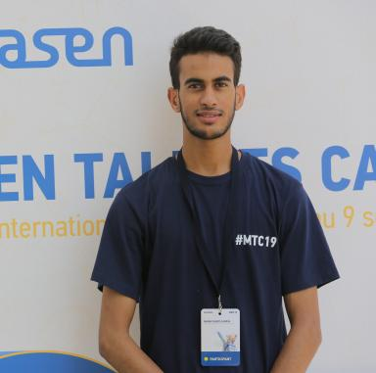 Ismail M'barki PhD Research SpecialistEMEAI DPA TS&DThe Dow Chemical Company

Identifiants chercheurs

- IdHAL : ismail-m039-barki
- ORCID : 0009-0004-7450-4479

Publications

Communication dans un congrès (1)

Performance evaluation of new polymer additives for technical ceramic shaping processes
Ismail M'Barki,Fabrice Rossignol,Anne Aimable,Graham Abramo,Burcu Çelikkol
Golden Jubilee Celebration of the 50th International Conference and Expo on Advanced Ceramics and Composites (ICACC 2026), Engineering Ceramics Division (ECD) of the American Ceramic Society (ACerS), Jan 2026, Daytona Beach, United States
Communication dans un congrès
hal-05550145v1

