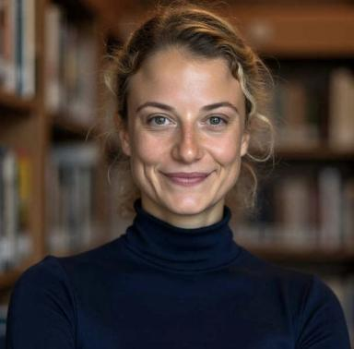 Isolde English Psychologist - Neuropsychologist and PhD candidate in Neuropsychology

Identifiants chercheurs

- IdHAL :
isolde-english

Présentation

I am a bi-national French and American neuropsychologist and PhD candidate with a deep interest in cognitive neuroscience, psychology, and the philosophy of mind. My research focuses on the complex relationships between the brain, cognition, and behavior.
My current work centers on cognitive rehabilitation, Cancer-Related Cognitive Impairment (CRCI), and the effects of chronic pain on cognitive functions. I am committed to developing evidence-based interventions to improve cognitive outcomes for patients affected by these conditions.
With experience in both clinical practice and academic research, I aim to bridge the gap between theoretical research and its practical applications, ensuring that the knowledge gained from research directly benefits individuals facing cognitive challenges.

Publications

Article dans une revue (1)

Improvement of Tardive Dyskinesia during Mindfulness Meditation
Maria Angela Santoro,Isolde English,Idil Sezer,Mickael Amagat,Frank Lyet al.
Neurology International, 2021, 13 (3), pp.439 - 444. ⟨10.3390/neurolint13030043⟩
Article dans une revue
hal-03353757v1

