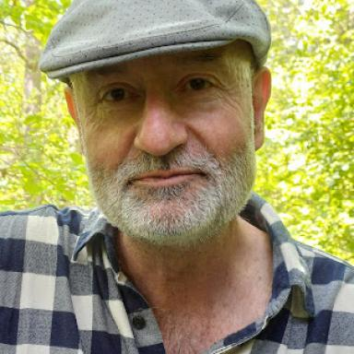 Jean-Marcel Piriou

Identifiants chercheurs

- IdHAL : jean-marcel-piriou
- ORCID : 0000-0002-4426-6594

Publications

Article dans une revue (8)

Diabatic processes modulating the vertical structure of the jet stream above the cold front of an extratropical cyclone: sensitivity to deep convection schemes
Meryl Wimmer,Gwendal Rivière,Philippe Arbogast,Jean-Marcel Piriou,Julien Delanoëet al.
Weather and Climate Dynamics, 2022, 3 (3), pp.863-882. ⟨10.5194/wcd-3-863-2022⟩
Article dans une revue
hal-03435603v2
The impact of deep convection representation in a global atmospheric model on the warm conveyor belt and jet stream during NAWDEX IOP6
Gwendal Rivière,Meryl Wimmer,Philippe Arbogast,Jean-Marcel Piriou,Julien Delanoëet al.
Weather and Climate Dynamics, 2021, 2 (4), pp.1011-1031. ⟨10.5194/wcd-2-1011-2021⟩
Article dans une revue
hal-03401330v2
The CNRM Global Atmosphere Model ARPEGE‐Climat 6.3: Description and Evaluation
Romain Roehrig,Isabelle Beau,D. Saint‐martin,Antoinette Alias,Bertrand Decharmeet al.
Journal of Advances in Modeling Earth Systems, 2020, 12 (7), ⟨10.1029/2020MS002075⟩
Article dans une revue
hal-03014003v1
Phenomenology of convection-parameterization closure
Jun-Ichi Yano,M. Bister,Ž. Fuchs,L. Gerard,V. T. J. Phillipset al.
Atmospheric Chemistry and Physics, 2013, 13, pp.4111-4131. ⟨10.5194/acp-13-4111-2013⟩
Article dans une revue
insu-03621041v1
Using continuous ground-based radar and lidar measurements for evaluating the representation of clouds in four operational models
Dominique Bouniol,Alain Protat,Julien Delanoë,Jacques Pelon,Jean-Marcel Piriouet al.
Journal of Applied Meteorology and Climatology, 2010, 49 (9), pp.1971-1991. ⟨10.1175/2010JAMC2333.1⟩
Article dans une revue
hal-00477076v1
CLOUDNET Continuous Evaluation of Cloud Profiles in Seven Operational Models Using Ground-Based Observations
A.J. Illingworth,R.J. Hogan,E.J. O'Connor,Dominique Bouniol,M.E. Brookset al.
Bulletin of the American Meteorological Society, 2007, 88 (6), pp.883-898. ⟨10.1175/BAMS-88-6-883⟩
Article dans une revue
hal-00164666v1
Identification of error sources in convective planetary boundary layer cloud forecasts using SIRTA observations
A. Mathieu,Jean-Marcel Piriou,M. Haeffelin,Philippe Drobinski,F. Vinitet al.
Geophysical Research Letters, 2006, 33, pp.L19812. ⟨10.1029/2006GL026001⟩
Article dans une revue
istex
hal-00110914v1
Modelling the diurnal cycle of deep precipitating convection over land with cloud-resolving models and single-column models
Françoise Guichard,J.-C. Petch,Jean-Luc Redelsperger,P. Bechtold,Jean-Pierre Chaboureauet al.
Quarterly Journal of the Royal Meteorological Society, 2004, 130 (604), pp.3139-3172. ⟨10.1256/qj.03.145⟩
Article dans une revue
hal-00268053v1

