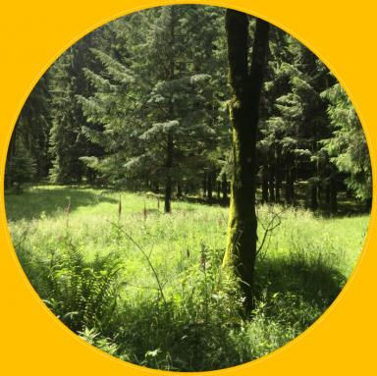 Jeremy Borderieux

Identifiants chercheurs

- IdHAL : jeremy-borderieux
- ORCID : 0000-0003-3993-1067
- IdRef : 277149126
- cv.identifier.google scholar : https://scholar.google.fr/citations?user=5YeOg-AAAAAJ

Publications

Article dans une revue (7)

Cool topoclimates promote cold-adapted plant diversity in temperate mountain forests.
Jeremy Borderieux,Emiel de Lombaerde,Karen de Pauw,Pieter Sanczuk,Pieter Vangansbekeet al.
Peer Community Journal, 2025, 5 (e16), ⟨10.24072/pcjournal.519⟩
Article dans une revue
hal-04889823v1
Extinction drives the climate-change-induced reshuffling of forest plant communities
Jeremy Borderieux,Josep Serra-Diaz
Nature Ecology & Evolution, 2024, 8 (4), pp.608-609. ⟨10.1038/s41559-024-02374-z⟩
Article dans une revue
hal-04684824v1
occTest : An integrated approach for quality control of species occurrence data
Josep Serra-Diaz,Jeremy Borderieux,Brian Maitner,Coline Boonman,Daniel Parket al.
Global Ecology and Biogeography, 2024, 33 (7), ⟨10.1111/geb.13847⟩
Article dans une revue
hal-04684834v1
Microclimate, an important part of ecology and biogeography
Julia Kemppinen,Jonas Lembrechts,Koenraad van Meerbeek,Jofre Carnicer,Nathalie Isabelle Chardonet al.
Global Ecology and Biogeography, 2024, 33 (6), pp.245-261. ⟨10.1111/geb.13834⟩
Article dans une revue (article de synthèse)
hal-04329908v2
Extinction drives recent thermophilization but does not trigger homogenization in forest understorey
Jeremy Borderieux,Jean-Claude Gegout,Josep Serra-Diaz
Nature Ecology & Evolution, 2024, 8, pp.695-704. ⟨10.1038/s41559-024-02362-3⟩
Article dans une revue
hal-04501662v1
High landscape‐scale forest cover favours cold‐adapted plant communities in agriculture–forest mosaics
Jeremy Borderieux,Jean‐claude Gégout,Josep Serra-Diaz
Global Ecology and Biogeography, 2023, 32 (6), pp.893-903. ⟨10.1111/geb.13676⟩
Article dans une revue
hal-04321793v1
The presence of shade-intolerant conifers facilitates the regeneration of Quercus petraea in mixed stands
Jeremy Borderieux,Yoan Paillet,Marine Dalmasso,Anders Mårell,Thomas Perotet al.
Forest Ecology and Management, 2021, 491, pp.1-10. ⟨10.1016/j.foreco.2021.119189⟩
Article dans une revue
hal-03195682v1

Communication dans un congrès (1)

What processes lie behind the recent changes of forest vegetation ? An insight on thermophilization and B-diversity
Jeremy Borderieux,Josep Serra-Diaz
SFE, GFO, EEF joint Meeting - International Conference on Ecological Science - Ecology and Evolution: new perspectives and societal challenges, Société Française d'Ecologie, GFO, EEF, Nov 2022, Metz, France
Communication dans un congrès
hal-04004503v1

Thèse (1)

Persistance ou adaptation de la flore forestière face aux effets conjugués du réchauffement climatique, de la fragmentation des forêts et du microclimat ?Persistence or adaptation of forest flora in the face of the intertwined effects of global warming, forest fragmentation and microclimate?
Jérémy Borderieux
Sciences agricoles. AgroParisTech, 2023. Français. ⟨NNT : 2023AGPT0013⟩
Thèse
tel-04550027v1

Mémoire d'étudiant (1)

Modelling the effect of tree species mixing on Quercus petraea regeneration with the French National Forest Inventory
Jeremy Borderieux
Silviculture, forestry. 2020
Mémoire d'étudiant
hal-03166803v1

