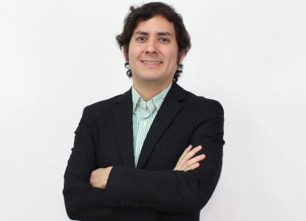 José María Rentería

Identifiants chercheurs

- IdHAL : jmrenteria
- ORCID : 0000-0001-6486-0032
- IdRef : 267837178

Présentation

Publications

Article dans une revue (1)

Inequality of Educational Opportunity and Time-Varying Circumstances: Longitudinal Evidence from Peru
José María Rentería
The Journal of Development Studies, 2022, pp.1-21. ⟨10.1080/00220388.2022.2113067⟩
Article dans une revue
hal-03768810v1

Autre publication scientifique (3)

Does teacher subjective well-being influence students' learning achievement? Evidence from public basic education in Peru
José María Rentería,Dante Solano
2022
Autre publication scientifique
halshs-03688119v1
The collateral effects of private school expansion in a deregulated market: Peru, 1996-2019
José María Rentería
2022
Autre publication scientifique
halshs-03704338v1
Inequality of educational opportunity and time-varying circumstances: Longitudinal evidence from Peru
José María Rentería
2019
Autre publication scientifique
halshs-02372538v1

Thèse (1)

On the Peruvian educational problem : inequality, privatization, and well-being
José Maria Renteria Vasquez
Economics and Finance. Université Panthéon-Sorbonne - Paris I, 2022. English. ⟨NNT : 2022PA01E039⟩
Thèse
tel-03997035v1

