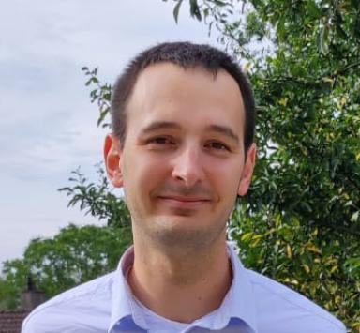 Joaquin Rodriguez Maître de conférences - Université Bourgogne Europe

Identifiants chercheurs

- IdHAL :
joaquinrodriguez1991
- ORCID :
0000-0002-1140-5412
- IdRef :
278588204
- arXiv :
rodriguez_j_2

Publications

Article dans une revue (3)

Pola4All: survey of polarimetric applications and an open-source toolkit to analyze polarization
Joaquin Rodriguez,Lew-Fock-Chong Lew-Yan-Voon,Renato Martins,Olivier Morel
Journal of Electronic Imaging, 2024, 33 (01), ⟨10.1117/1.JEI.33.1.010901⟩
Article dans une revue
hal-04365612v1
A Practical Calibration Method for RGB Micro-Grid Polarimetric Cameras
Joaquin Rodriguez,Lew F.C. Lew Yan Voon,Renato Martins,Olivier Morel
IEEE Robotics and Automation Letters, 2022, 7 (4), pp.9921-9928. ⟨10.1109/LRA.2022.3192655⟩
Article dans une revue
hal-03758271v1
A Prostate MRI Segmentation Tool Based on Active Contour Models Using a Gradient Vector Flow
Joaquín Rodríguez,Gilberto Ochoa-Ruiz,Christian Mata
Applied Sciences, 2020, 10 (18), pp.6163. ⟨10.3390/app10186163⟩
Article dans une revue
hal-04009133v1

Communication dans un congrès (2)

YOLO-based Multi-Modal Analysis of Vineyards using RGB-D Detections
Thibault Clamens,J Rodriguez,Mickael Delamare,Lew F.C. Lew Yan Voon,Eric Fauvetet al.
5th International Conference on Advances in Signal Processing and Artificial Intelligence (ASPAI' 2023), Sergey Y. Yurish, Jun 2023, Tenerife, Spain. pp.292, ⟨10.13140/RG.2.2.27945.77924⟩
Communication dans un congrès
hal-05307792v1
Decomposition-based integer programming for coordinated train rerouting and rescheduling
Peng Guo,Paola Pellegrini,Joaquin Rodriguez,Raffaele Pesenti
21th conference ROADEF of the French society of operations research and decision aid, Feb 2020, Montpellier, France
Communication dans un congrès
hal-04666255v1

Thèse (1)

Calibration and 3D vision with a color-polarimetric camera
Joaquin Rodriguez
Signal and Image Processing. Université Bourgogne Franche-Comté, 2023. English. ⟨NNT : 2023UBFCK062⟩
Thèse
tel-04598248v1

