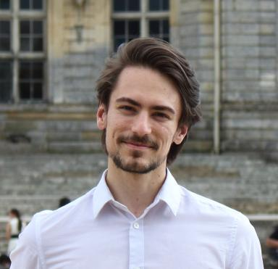 Johan ACHARD Doctoral Student in Cognitives Sciences at Universiré of Franche-Comté

Identifiants chercheurs

- IdHAL : johan-achard
- ORCID : 0000-0002-9135-8301

Présentation

PhD Student with interesting pluridisciplinary profile in Cognitive Sciences, included cognitive psychology, HCI, neurosciences, computer science, with expertise in modelling method and data science.

Publications

Article dans une revue (1)

Extending continuous flow models of immediate decision reports to delayed decision reports
Johan Achard,Thibault Gajdos,Mathieu Servant
Journal of Experimental Psychology: General, In press
Article dans une revue
hal-04940853v2

