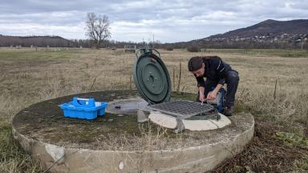 JORDAN LABBE Post-Doctorant à l'Université de Franche-Comté UMR CNRS 6249 Chrono-Environnement, Besançon - Projet MOD-ALL²

Présentation

I am working on the impact of climate and socio-economic change on alluvial hydrosystem, especially on the Allier alluvial aquifer (Auvergne, France) since my PhD and now in Post-Doctorate. All this work is part of the Observation Service AUVERWATCH project (SNO H+, SNO RENOIR, eLTER, OZCAR), more information can be found at https://hplus.ore.fr/en/auverwatch/
Numerical modelling (Groundwater Vista, MODFLOW) is the main tool which is used in this project to study and reproduce the behaviour of the Allier alluvial aquifer. Many filed surveys are realized to supplement existing data (water-level probes, ERT, sampling for hydrochemistry...)The work is followed by water stakeholders and the purpose is to calibrate a model that is to be tested with management scenarios, especially on domestic water pumping sites.

Publications

Communication dans un congrès (2)

Alluvial aquifer modeling with MODFLOW in the case of a well-field facing global change (AUVERWATCH Project)
Jordan Labbe,Hélène Celle,Pierre Nevers,Victor Klaba,Jean-Luc Devidalet al.
The International Association of Hydrogeologists, IAH2023, Sep 2023, Cap Town, South Africa
Communication dans un congrès
hal-04274181v1
Characterization of groundwater flow by fiber optic temperature measurement
Jean-Charles Beugnot,Kien Phan Huy,Alexandre Matic,Maxime Romanet,Maxime Zerbibet al.
Conférence Guided Optics & Sensor Systems, Jun 2022, Bordeaux, France
Communication dans un congrès
hal-04032300v1

