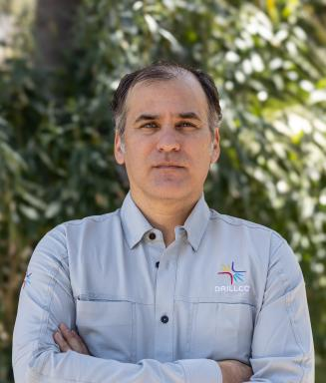 Jorge AISING Mines Paris – PSL Associate Researcher

Identifiants chercheurs

- IdHAL : jorge-aising
- ORCID : 0009-0004-2622-8051
- cv.identifier.google scholar : https://scholar.google.fr/citations?user=ZfCP7UMAAAAJ

Présentation

My research focuses on developing a physical understanding of percussive drilling, particularly the interaction between rock and tools in down-the-hole (DTH) hammer drilling conditions. I study the coupled effects of impact dynamics, rock fragmentation, and accumulated damage using experimental and physics-based modeling approaches.

Publications

Article dans une revue (4)

Multi-criteria validation of hi-fidelity numerical model of impact breakage: towards next generation percussion drill simulation
Xiaowei Yang,Jiansheng Xiang,Sadjad Naderi,Yanghua Wang,Jorge Aisinget al.
International Journal of Rock Mechanics and Mining Sciences, 2025, 191, pp.106125. ⟨10.1016/j.ijrmms.2025.106125⟩
Article dans une revue
hal-05451448v1
A Study of Rock Breakage Under Extreme Submerged Confining Pressure: Can DTH Hammer Drilling Deliver
Sadjad Naderi,Laurent Gerbaud,Naveen Velmurugan,Xiang Jiansheng,Xiaowei Yanget al.
Rock Mechanics and Rock Engineering, 2025, ⟨10.1007/s00603-025-04626-1⟩
Article dans une revue
hal-05347612v1
Correlation of Damage in Rocks Dynamically Loaded by Percussive Tools Using Piston Coefficient of Restitution (COR)
Jorge Aising,Laurent Gerbaud,Hedi Sellami,Pascale Sénéchal,Peter Moonen
Rock Mechanics and Rock Engineering, 2024, ⟨10.1007/s00603-024-04303-9⟩
Article dans une revue
hal-04855997v1
Experimental analysis of rock fragmentation induced by single percussive impact
Jorge Aising,Laurent Gerbaud,Hedi Sellami
International Journal of Rock Mechanics and Mining Sciences, 2024, 181, pp.105843. ⟨10.1016/j.ijrmms.2024.105843⟩
Article dans une revue
hal-04710525v1

Communication dans un congrès (2)

Where Does the Energy Go in Percussion Drilling? FDEM's Answer
X. Yang,J. Xiang,S. Naderi,Y. Wang,J. Lathamet al.
58th U.S. Rock Mechanics/Geomechanics Symposium, Jun 2024, Golden, France. ⟨10.56952/arma-2024-0952⟩
Communication dans un congrès
hal-04880209v1
A Study of Rock Breakage Under Extreme Submerged Confining Pressure: Can DTH Hammer Drilling Deliver?
Laurent Gerbaud,Naveen Velmurugan,Jorge Aising,C. Chambres,S. Naderiet al.
58th U.S. Rock Mechanics/Geomechanics Symposium, Jun 2024, Golden, France. ⟨10.56952/arma-2024-0788⟩
Communication dans un congrès
hal-04880182v1

Pré-publication, Document de travail (1)

Experimental Analysis of Rock Fragmentation Induced by Single Percussive Impact
Jorge Aising,Laurent Gerbaud,Hedi Sellami
2025
Pré-publication, Document de travail
hal-04880090v1

