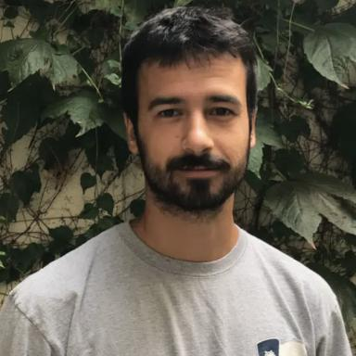 Jules Cauzinille

Identifiants chercheurs

- IdHAL : jules-cauzinille
- ORCID : 0000-0002-8604-1801
- arXiv : cauzinille_j_1
- cv.identifier.google scholar : https://scholar.google.fr/citations?user=w0z7DzcAAAAJ

Publications

Article dans une revue (4)

Multi-interaction: a new open-access approach for studying multimodal communication and interactions across species
L. Habib-Dassetto,P. Best,J. Cauzinille,A. Marques,M. Adetet al.
Animal Behaviour, 2026, 234, pp.123526. ⟨10.1016/j.anbehav.2026.123526⟩
Article dans une revue
hal-05562195v2
Opportunistic Observation of Long-Finned Pilot Whales Interacting with a Solitary Humpback Whale in the Gascogne Gulf (Northwest Atlantic)
Paul Best,Lise Habib-Dassetto,Jules Cauzinille,Thierry Legou,Fabienne Delfouret al.
Aquatic Mammals, 2025, 51 (6), pp.515-520. ⟨10.1578/AM.51.6.2025.515⟩
Article dans une revue
hal-05497421v1
Applying machine learning to primate bioacoustics: review and perspectives
Jules Cauzinille,Benoît Favre,Ricard Marxer,Arnaud Rey
American Journal of Primatology, In press, ⟨10.1002/ajp.23666⟩
Article dans une revue
hal-04658068v1
Automatic detection for bioacoustic research: a practical guide from and for biologists and computer scientists
Arik Kershenbaum,Çağlar Akçay,Lakshmi Babu-Saheer,Alex Barnhill,Paul Bestet al.
Biological Reviews, 2024, ⟨10.1111/brv.13155⟩
Article dans une revue
hal-04741895v1

Communication dans un congrès (4)

Social Ambiguity and Multimodal Interactions in Guinea baboons
Lise Habib-Dassetto,Mathilde Adet,Jules Cauzinille,Arthur Marques,Alban Lemassonet al.
EVOLANG, May 2024, Madison (WI), United States
Communication dans un congrès
hal-04650490v1
Investigating self-supervised speech models' ability to classify animal vocalizations: The case of gibbon's vocal signatures
Jules Cauzinille,Benoît Favre,Ricard Marxer,Dena Clink,Abdul Hamid Ahmadet al.
Interspeech 2024, Sep 2024, Kos / Greece, Greece. pp.132-136, ⟨10.21437/Interspeech.2024-1096⟩
Communication dans un congrès
hal-04693119v1
From speech to primate vocalizations: self-supervised deep learning as a comparative approach
Jules Cauzinille,Benoît Favre,Ricard Marxer,Arnaud Rey
Proceedings of the 15th International Conference on the Evolution of Language (EVOLANG XV), Gary Lupyan, May 2024, Madison, United States. pp.64, ⟨10.17617/2.3587960⟩
Communication dans un congrès
hal-04608044v1
Annotation of expressive dimensions on a multimodal French corpus of political interviews
Jules Cauzinille,Marc Evrard,Nikita Kiselov,Albert Rilliard
First Workshop on Natural Language Processing for Political Sciences (PoliticalNLP), Jun 2022, Marseille, France. pp.91-97
Communication dans un congrès
hal-04259166v1

Poster de conférence (2)

Underwater behaviour of Globicephala melas
Paul Best,Lise Habib-Dasetto,Jules Cauzinille,Ricard Marxer,Fabienne Delfouret al.
IBAC 2025, Sep 2025, Kerteminde, France
Poster de conférence
hal-05497429v1
Social Ambiguity and Multimodal Interactions in Guinea Baboons
Lise Habib-Dassetto,Jules Cauzinille,Mathilde Adet,Arthur Marques,Alban Lemassonet al.
EVOLANG, May 2024, Madison (US-WI), United States
Poster de conférence
hal-04650503v1

