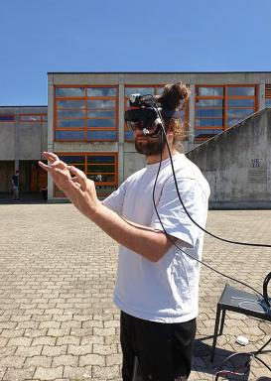 Julien Mercier

Identifiants chercheurs

- IdHAL :
julien-mercier

Publications

Article dans une revue (4)

IMPACT OF GEOLOCATION DATA ON AUGMENTED REALITY USABILITY: A COMPARATIVE USER TEST
Julien Mercier,N. Chabloz,G. Dozot,C. Audrin,O. Ertzet al.
ISPRS International Archives of the Photogrammetry, Remote Sensing and Spatial Information Sciences, 2023, XLVIII-4/W7-2023, pp.133-140. ⟨10.5194/isprs-archives-XLVIII-4-W7-2023-133-2023⟩
Article dans une revue
hal-04183735v1
BiodivAR: A Cartographic Authoring Tool for the Visualization of Geolocated Media in Augmented Reality
Julien Mercier,Nicolas Chabloz,Gregory Dozot,Olivier Ertz,Erwan Bocheret al.
ISPRS International Journal of Geo-Information, 2023, 12 (2), pp.61. ⟨10.3390/ijgi12020061⟩
Article dans une revue
hal-04183730v1
Third of patients have gustatory dysfunction 9 months after SARS-CoV-2 infection: the ANOSVID study
Timothée Klopfenstein,Can Tipirdamaz,Vincent Gendrin,Molka Osman,Julien Mercieret al.
International Journal of Infectious Diseases, 2022, 119, pp.114-116. ⟨10.1016/j.ijid.2022.03.053⟩
Article dans une revue
hal-05097764v1
Olfactory dysfunction in COVID‐19, new insights from a cohort of 353 patients: The ANOSVID study
Julien Mercier,Molka Osman,Kevin Bouiller,Can Tipirdamaz,Vincent Gendrinet al.
Journal of Medical Virology, 2022, 94 (10), pp.4762-4775. ⟨10.1002/jmv.27918⟩
Article dans une revue
hal-05097756v1

