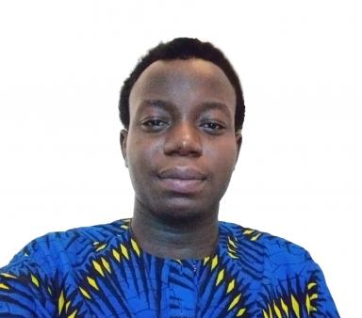 Peniel Adounkpe

Identifiants chercheurs

- IdHAL : julien-yise-peniel-adounkpe
- ORCID : 0000-0001-9326-0669

Publications

Article dans une revue (1)

Deep Learning at Two Timescales: Dual Neural Networks for Predicting Fast Urban and Slow Karst Floods
Peniel Adounkpe,Valentin Wendling,Alain Dezetter,Bruno Arfib,Kalil Traoréet al.
Inżynieria Mineralna, 2025, 3 (2), ⟨10.29227/IM-2025-02-03-27⟩
Article dans une revue
hal-05360721v1

Communication dans un congrès (2)

A Comparison Between Adam and Levenberg–Marquardt Optimizers for the Prediction of Extremes: Case Study for Flood Prediction with Artificial Neural Networks
Peniel Adounkpe,Valentin Wendling,Alain Dezetter,Bruno Arfib,Guillaume Artigueet al.
ITISE 2025 - 11th International Conference on Time Series and Forecasting, Jul 2025, Gran Canaria, Spain. pp.12, ⟨10.3390/engproc2025101012⟩
Communication dans un congrès
hal-05208914v1
Flash flood and vigilance forecasting of a complex, anthropogenic karst hydrosystem using neural networks. Application to the Las coastal river at Toulon (South-East France)
Peniel Adounkpe,Romane Berthelin,Valentin Wendling,Guillaume Artigue,A. Dezetteret al.
Eurokarst 2024, Jun 2024, Rome, Italy
Communication dans un congrès
hal-04625529v1

Poster de conférence (2)

Jumeaux Numériques d’Hydrosystèmes pour la Gestion des Crues : Ombre numérique ou véritable jumeau numérique ?
Peniel Adounkpe,Guillaume Artigue,Romane Berthelin,A. Dezetter,Octavian Dobriceanet al.
Séminaire IMT « Data Analytics & Artificial Intelligence », Nov 2024, Nantes, France. 2024
Poster de conférence
hal-05032952v1
Labcom Hydr.IA: a joint Company-Academic laboratory to develop new flood forecasting services. Case Study on the Nîmes Flash-Floods (Southeastern France)
Romane Berthelin,Peniel Adounkpe,Guillaume Artigue,Nanée Chahinian,A. Dezetteret al.
AGU 2023, Dec 2023, San Francisco, United States. 2023
Poster de conférence
hal-04343943v1

