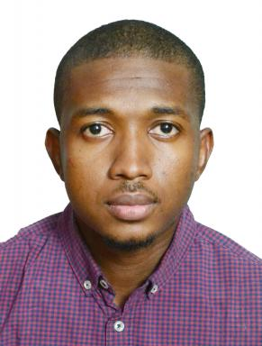 Kabir Bashir Shariff 3rd year PhD student

Publications

Article dans une revue (3)

Towards a Generalized Tidal Turbine Wake Analytical Model for Turbine Placement in Array Accounting for Added Turbulence
Kabir Bashir Shariff,Sylvain S. Guillou
Energies, 2025, 18, pp.2257. ⟨10.3390/en18092257⟩
Article dans une revue
hal-05183343v1
A Generalized Empirical Model for Velocity Deficit and Turbulent Intensity in Tidal Turbine Wake Accounting for the Effect of Rotor-Diameter-to-Depth Ratio
Kabir Bashir Shariff,Sylvain S Guillou
Energies, 2024, 17, ⟨10.3390/en17092065⟩
Article dans une revue
hal-04613212v1
An empirical model accounting for added turbulence in the wake of a full-scale turbine in realistic tidal stream conditions
Kabir Bashir Shariff,Sylvain S. Guillou
Applied Ocean Research, 2022, 128, pp.103329. ⟨10.1016/j.apor.2022.103329⟩
Article dans une revue
hal-04614929v1

Poster de conférence (1)

Added turbulence empirical model for a single tidal turbine
Kabir Bashir Shariff,Sylvain S. Guillou
Seanergy 2022, Jun 2022, Le Havre, France. 2022
Poster de conférence
hal-03768968v1

Communication dans un congrès (2)

An empirical wake model accounting for velocity deficit and turbulence intensity in a simple tidal park
Kabir Bashir Shariff,Sylvain S. Guillou
Journées de l'Hydrodynamique, Université de Poitiers, Nov 2022, Poitier, France
Communication dans un congrès
hal-03976984v1
Developing an empirical model for added turbulence in a wake of tidal turbine
Kabir Bashir Shariff,Sylvain S. Guillou
25 ème Congrès Français de Mécanique, Aug 2022, Nantes, France
Communication dans un congrès
hal-03768506v1

