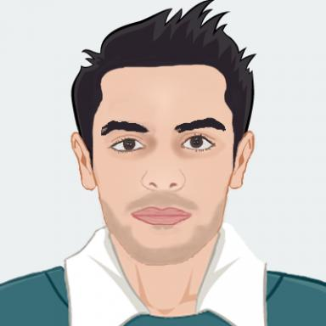 Lakhdar Meftah

Identifiants chercheurs

- IdHAL : lakhdar-meftah
- ORCID : 0000-0002-0292-3795
- IdRef : 24490040X

Présentation

Publications

Article dans une revue (1)

Empowering Mobile Crowdsourcing Apps with User Privacy Control
Lakhdar Meftah,Romain Rouvoy,Isabelle Chrisment
Journal of Parallel and Distributed Computing, 2020, pp.15. ⟨10.1016/j.jpdc.2020.07.011⟩
Article dans une revue
hal-02910246v1

Communication dans un congrès (4)

Capturing Privacy-preserving User Contexts with IndoorHash
Lakhdar Meftah,Romain Rouvoy,Isabelle Chrisment
DAIS 2020 - 20th IFIP International Conference on Distributed Applications and Interoperable Systems, Jun 2020, Valletta, Malta. ⟨10.1007/978-3-030-50323-9_2⟩
Communication dans un congrès
hal-02541391v1
Testing Nearby Peer-to-Peer Mobile Apps at Large
Lakhdar Meftah,Romain Rouvoy,Isabelle Chrisment
MOBILESoft 2019 - 6th IEEE/ACM International Conference on Mobile Software Engineering and Systems, May 2019, Montréal, Canada
Communication dans un congrès
hal-02059088v1
FOUGERE: User-Centric Location Privacy in Mobile Crowdsourcing Apps
Lakhdar Meftah,Romain Rouvoy,Isabelle Chrisment
DAIS 2019 - 19th IFIP International Conference on Distributed Applications and Interoperable Systems, Jun 2019, Kongens Lyngby, Denmark. pp.116-132, ⟨10.1007/978-3-030-22496-7_8⟩
Communication dans un congrès
hal-02121311v1
AndroFleet: Testing WiFi Peer-to-Peer Mobile Apps in the Large
Lakhdar Meftah,Maria Gomez,Romain Rouvoy,Isabelle Chrisment
ASE 2017 - 32nd IEEE/ACM International Conference on Automated Software Engineering , Oct 2017, Urbana-Champaign, Illinois, United States
Communication dans un congrès
hal-01574466v1

Thèse (1)

Towards Privacy-sensitive Mobile Crowdsourcing
Lakhdar Meftah
Software Engineering [cs.SE]. University of Lille, 2019. English. ⟨NNT : ⟩
Thèse
tel-02399716v2

