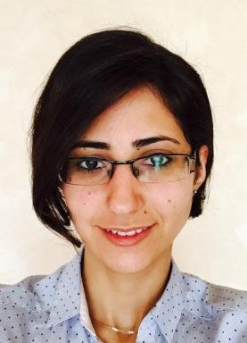 Lara QASIM

Identifiants chercheurs

- IdHAL :
lara-qasim

Présentation

Contact me:
Lara QASIM
Laboratoire Genie IndustrielCentraleSupélecUniversité Paris-Saclay
9 rue Joliot-CurieBatiment Bouygues91190 Gif-sur-YvetteFrance
E-mail : lara.qasim@centralesupelec.fr Find me also on: https://www.linkedin.com/in/lara-qasim-36540045/

Publications

Article dans une revue (2)

System reconfiguration ontology to support model-based systems engineering: Approach linking design and operations
Lara Qasim,Andreas Makoto Hein,Marija Jankovic,Sorin Olaru,Jean-Luc Garnier
Systems Engineering, 2023, 26 (4), pp.347-364. ⟨10.1002/sys.21661⟩
Article dans une revue
hal-04371940v1
A Model-Based Method for System Reconfiguration
Lara Qasim,Andreas Makoto Hein,Sorin Olaru,Jean-Luc Garnier,Marija Jankovic
Journal of Mechanical Design, 2022, 144 (1), ⟨10.1115/1.4051889⟩
Article dans une revue
hal-03325840v1

Chapitre d'ouvrage (2)

An Ontology for System Reconfiguration: Integrated Modular Avionics IMA Case Study
Lara Qasim,Andreas Makoto Hein,Sorin Olaru,Marija Jankovic,Jean-Luc Garnier
Recent Trends and Advances in Model Based Systems Engineering, Springer International Publishing, pp.189-198, 2022, ⟨10.1007/978-3-030-82083-1_17⟩
Chapitre d'ouvrage
hal-03758711v1
Model-based System Reconfiguration: a descriptive study of current industrial challenges
Lara Qasim,Marija Jankovic,Sorin Olaru,Jean-Luc Garnier
Eric Bonjour; Daniel Krob; Luca Palladino; François Stephan. Complex Systems Design & Management. Proceedings of the Ninth International Conference on Complex Systems Design & Management, CSD&M Paris 2018, Springer International Publishing, pp.97-108, 2018, ⟨10.1007/978-3-030-04209-7_8⟩
Chapitre d'ouvrage
hal-02001165v1

Autre publication scientifique (1)

Model-based system Reconfiguration
Marija Jankovic,Lara Qasim
2017
Autre publication scientifique
hal-01770952v1

Thèse (1)

System reconfiguration : A Model based approach; From an ontology to the methodology bridging engineering and operations
Lara Qasim
Mechanical engineering [physics.class-ph]. Université Paris-Saclay, 2020. English. ⟨NNT : 2020UPAST031⟩
Thèse
tel-03242294v1

