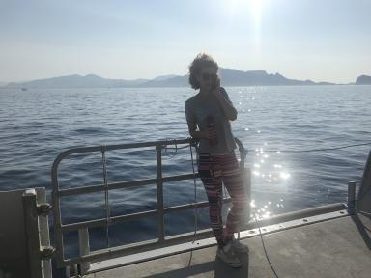 Laure PAPILLON AI Analyses Chimiques

Identifiants chercheurs

- IdHAL : laure-papillon

Publications

Article dans une revue (7)

Marine litter, microplastic pollution and organic additives assessments in polar areas through an opportunistic cruise ship-based approach
Olivia Gerigny,Mélanie Ourgaud,Laure Papillon,Christophe Brach-Papa,Jean-Louis Gonzalezet al.
Marine Pollution Bulletin, 2026, 225, pp.119216. ⟨10.1016/j.marpolbul.2026.119216⟩
Article dans une revue
hal-05448744v1
Comparative analysis of microplastics detection methods applied to marine sediments: A case study in the Bay of Marseille
Olivia Gerigny,Gustavo Blanco,Urmas Lips,Natalja Buhhalko,Leelou Chouteauet al.
Marine Pollution Bulletin, 2024, 207, pp.116787. ⟨10.1016/j.marpolbul.2024.116787⟩
Article dans une revue (article de synthèse)
hal-04671526v1
What happens to biomass burning-emitted particles in the ocean? A laboratory experimental approach based on their tracers
Juan Miguel González-Sánchez,Christos Panagiotopoulos,Candice Antich,Laure Papillon,Nicole Garciaet al.
Science of the Total Environment, 2024, 907, pp.167770. ⟨10.1016/j.scitotenv.2023.167770⟩
Article dans une revue
hal-04268856v1
Identification and Quantification of Microplastics in the Marine Environment Using the Laser Direct Infrared (LDIR) Technique
Mélanie Ourgaud,Nam Ngoc Phuong,Laure Papillon,Christos Panagiotopoulos,François Galganiet al.
Critical Reviews in Environmental Sciences and Technology, 2022, 56 (14), pp.9999-10009. ⟨10.1021/acs.est.1c08870⟩
Article dans une revue
hal-05416744v1
Identification and Quantification of Microplastics in the Marine Environment Using the Laser Direct Infrared (LDIR) Technique
Mélanie Ourgaud,Nam Ngoc Phuong,Laure Papillon,Christos Panagiotopoulos,François Galganiet al.
Environmental Science and Technology, 2022, 56 (14), pp.9999-10009. ⟨10.1021/acs.est.1c08870⟩
Article dans une revue
hal-03705932v1
Organic additive release from plastic to seawater is lower under deep-sea conditions
Vincent Fauvelle,Marc Garel,Christian Tamburini,D. Nerini,Javier Castro-Jiménezet al.
Nature Communications, 2021, 12 (1), ⟨10.1038/s41467-021-24738-w⟩
Article dans une revue
hal-03293644v1
Environmental occurrence of phthalate and organophosphate esters in sediments across the Gulf of Lion (NW Mediterranean Sea)
Nigar Alkan,Ali Alkan,Javier Castro-Jiménez,Florian Royer,Laure Papillonet al.
Science of the Total Environment, In press, 760, pp.143412. ⟨10.1016/j.scitotenv.2020.143412⟩
Article dans une revue
hal-02994869v2

