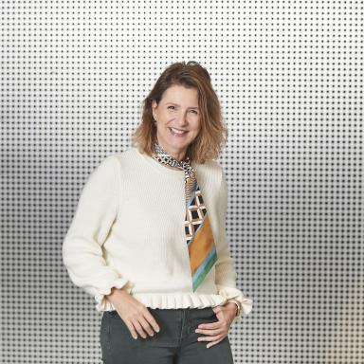 Laurence Viale

Identifiants chercheurs

- IdHAL : laurence-viale
- ORCID : 0000-0003-4658-9511

Publications

Article dans une revue (8)

Repenser la supply chain et son management pour faire face aux enjeux futurs : le développement durable source d’innovations
Dorsaf Zouari,Laurence Viale,Stéphano Vacher
Logistique & Management, 2024, 32 (1), pp.1-4. ⟨10.1080/12507970.2024.2314393⟩
Article dans une revue
hal-04685579v1
A mixed-methods approach to identifying buyers’ competencies for enabling innovation
Laurence Viale,Salomée Ruel,Dorsaf Zouari
International Journal of Logistics Research and Applications, 2022, 26 (9), pp.1102-1123. ⟨10.1080/13675567.2021.2020226⟩
Article dans une revue
hal-03695531v1
Open innovation as a practice to enhance sustainable supply chain management in SMEs
Laurence Viale,Stéphano Vacher,Isaline Frelet
Supply Chain Forum: An International Journal, 2022, 23 (4), pp.363-373. ⟨10.1080/16258312.2022.2136979⟩
Article dans une revue
hal-03868897v1
For a deeper understanding of the relationships between &quot;Firm Size&quot; and supply chain digitalization: An empirical investigation
Salomée Ruel,Laurence Viale,Dorsaf Zouari
. International Journal of Integrated Supply Management, 2022, ⟨10.1504/ijism.2023.10048954⟩
Article dans une revue
hal-03701279v1
A deeper understanding of the relationships between 'firm size' and supply chain digitalisation: an empirical investigation
Salomée Ruel,Laurence Viale,Dorsaf Zouari
International Journal of Integrated Supply Management, 2022, 16 (1), pp.1. ⟨10.1504/IJISM.2023.127649⟩
Article dans une revue
hal-03933846v1
Impact of digitalization on procurement: the case of robotic process automation
Laurence Viale,Dorsaf Zouari
Supply Chain Forum: An International Journal, 2020, Digital Supply Chain: challenges and future directions, 21 (3), pp.185-195. ⟨10.1080/16258312.2020.1776089⟩
Article dans une revue
hal-03695535v1
Does digitalising the supply chain contribute to its resilience?
Dorsaf Zouari,Salomé Ruel,Laurence Viale
International Journal of Physical Distribution and Logistics Management, 2020, 51 (2), pp.149-180. ⟨10.1108/IJPDLM-01-2020-0038⟩
Article dans une revue
hal-03695527v1
Intra-functional coordination: the case of purchasing during innovation in the agri-food sector
Laurence Viale
Supply Chain Forum: An International Journal, 2019, 20 (2), pp.104-115. ⟨10.1080/16258312.2019.1610493⟩
Article dans une revue
hal-03695516v1

Communication dans un congrès (1)

From early supplier involvement toward early purchasing involvement: Story of a radical co-innovation in the energy industry
Karine Evrard Samuel,Dorsaf Zouari,Laurence Viale
IMP Conference, The IMP Group, 2015, Kolding, Denmark
Communication dans un congrès
hal-02056226v1

Chapitre d'ouvrage (1)

Sustainable Purchasing and Value Creation in the Circular Economy: Spotlight on Carbios, a Highly Innovative Chemical Company
Laurence Viale,Nathalie Merminod,Damien Talbot
Pedagogical Case Studies in Purchasing and Supply Management, Springer Nature Switzerland, pp.307-325, 2026, ⟨10.1007/978-3-032-12235-3_17⟩
Chapitre d'ouvrage
hal-05521032v1

