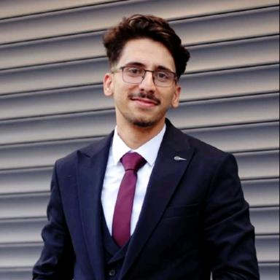 Layth KASHOU PhD student working on “Optimization under Uncertainty and Learning for Adaptive Reconfigurable Manufacturing Systems”, within an international industrial–academic collaboration between FAACTOPI Company, Université Clermont Auvergne – LIMOS, and University of Michigan.

Identifiants chercheurs

- IdHAL : layth-kashou
- ORCID : 0009-0000-3939-8915

Publications

Communication dans un congrès (1)

Benders decomposition for robust balancing of production lines
Layth Kashou,André Rossi,Evgeny Gurevsky,Rui S. Shibasaki
27th Congress of the French Society of Operations Research and Decision Aid (ROADEF 2026), Feb 2026, Tours, France
Communication dans un congrès
hal-05525199v1

