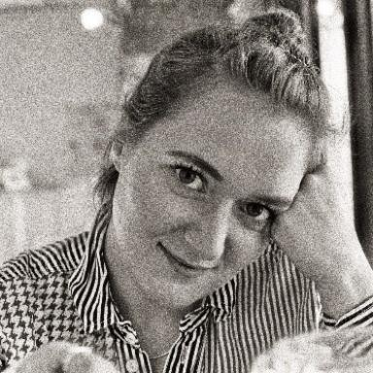 Léa Lefebvre

Publications

Article dans une revue (5)

Does urban environment at birth and adolescence affect cardiometabolic morbidity in adolescents? Results from the PARIS birth cohort study
Léa Lefebvre,Emmanuel Marion,Frédérique Prédali,Malika Viola,Thierry Feuilletet al.
Health & Place, 2026, 98, pp.103622. ⟨10.1016/j.healthplace.2026.103622⟩
Article dans une revue
hal-05506521v1
Does urban environment at birth and adolescence affect cardiometabolic morbidity in adolescents? Results from the PARIS birth cohort study
Léa Lefebvre,Emmanuel Marion,Frédérique Prédali,Malika Viola,Thierry Feuilletet al.
Health & Place, 2026, 98, pp.103622. ⟨10.1016/j.healthplace.2026.103622⟩
Article dans une revue
hal-05573052v1
Body mass index trajectories from birth to adolescence and associated factors in the PARIS cohort
Léa Lefebvre,Riem Nur,Thomas Grunemwald,Karima Hamrene,Céline Rodaet al.
Acta Paediatrica, 2025, 114 (6), pp.1305-1314. ⟨10.1111/apa.17570⟩
Article dans une revue
hal-05525327v1
Early exposure to sunlight and allergic morbidity: The PARIS birth cohort
Léa Lefebvre,Hélène Amazouz,Fanny Rancière,Isabelle Momas
Science of the Total Environment, 2024, 930, pp.172543. ⟨10.1016/j.scitotenv.2024.172543⟩
Article dans une revue
hal-04624946v1
Unsupervised identification of cardiometabolic profiles among adolescents: findings from the PARIS birth cohort study
Léa Lefebvre,Thomas Grunemwald,Karima Hamrene,Céline Roda,Isabelle Momas
European Journal of Pediatrics, 2024, 183 (2), pp.715-725. ⟨10.1007/s00431-023-05311-7⟩
Article dans une revue
hal-04624948v1

