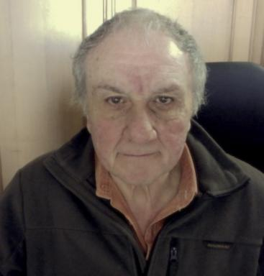 Luigi Russo Luigi Russo, MD. Researcher at the Huggins Laboratory, Genzano di Roma

Publications

Article dans une revue (1)

Neutron spectrometry in radionuclide-based reference neutron fields at the ASNR Cadarache CEZANE facility using the NCT-WES single-moderator directional spectrometer
Roberto Bedogni,M. Caballero-Pacheco,Luigi Russo,A. Castro Campoy,F. Lopes Frigiet al.
The European Physical Journal Plus, 2025, 140, pp.809. ⟨10.1140/epjp/s13360-025-06716-z⟩
Article dans une revue
hal-05023309v1

Communication dans un congrès (4)

Hydrophobic molecules and hemodialytic treatment.
Luigi Russo
World Congress of Nephrology, Apr 2011, Vancouver, Canada
Communication dans un congrès
hal-03636210v1
Effect of uremic state on binding of middle molecules: influence on power of artificial excretory procedures
Luigi Russo
Fourth Congress of the International Society for Artificial Organs, Abstracts, Artificial Organs (1983) 7, 40, Nov 1983, Kyoto, Japan
Communication dans un congrès
hal-03652179v1
Fluorimetric determination of high levels of middle molecules in plasma of uremic patients under treatment with hemodialysis or hemofiltration.
Luigi Russo
Xth ESAO Annual Meeting. Abstract Book, 1983; p.83., Sep 1983, Bologna, Italy. pp.73
Communication dans un congrès
hal-03879536v1
Plasma middle molecules after cardio-pulmonary bypass: appearance of free and bound polypeptides
Luigi Russo
VIII ESAO Annual Meeting, Copenaghen, Denmark, 1981, Aug 1981, Copenaghen, Denmark
Communication dans un congrès
hal-03649475v1

