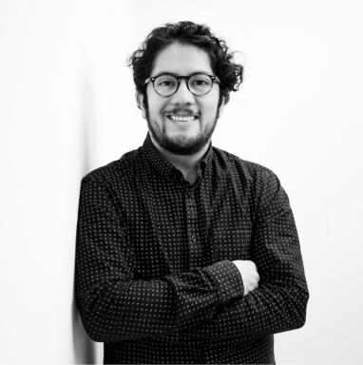 Luis Gómez-Nava

Publications

Article dans une revue (7)

Fish shoals resemble a stochastic excitable system driven by environmental perturbations
Luis Gómez-Nava,Robert Lange,Pascal Klamser,Juliane Lukas,Lenin Arias-Rodriguezet al.
Nature Physics, 2023, 19 (5), pp.663-669. ⟨10.1038/s41567-022-01916-1⟩
Article dans une revue
hal-04764877v1
Live fish learn to anticipate the movement of a fish-like robot *
David Bierbach,Luis Gómez-Nava,Fritz Francisco,Juliane Lukas,Lea Musioleket al.
Bioinspiration and Biomimetics, 2022, 17 (6), pp.065007. ⟨10.1088/1748-3190/ac8e3e⟩
Article dans une revue
hal-04764906v1
Impact of Variable Speed on Collective Movement of Animal Groups
Pascal Klamser,Luis Gómez-Nava,Tim Landgraf,Jolle Jolles,David Bierbachet al.
Frontiers in Physics, 2021, 9, ⟨10.3389/fphy.2021.715996⟩
Article dans une revue
hal-03511036v1
Kinetic and macroscopic models for active particles exploring complex environments with an internal navigation control system
Luis Gómez Nava,Thierry Goudon,Fernando Peruani
Mathematical Models and Methods in Applied Sciences, 2021, 31 (08), pp.1691-1717. ⟨10.1142/S0218202521500366⟩
Article dans une revue
hal-03510981v1
A novel approach to chemotaxis: Active particles guided by internal clocks
Luis Gómez Nava,Robert Grossmann,Marius Hintsche,Carsten Beta,Fernando Peruani
EPL - Europhysics Letters, 2020, 130 (6), pp.68002. ⟨10.1209/0295-5075/130/68002⟩
Article dans une revue
hal-02905641v1
Markovian robots: minimal navigation strategies for active particles
Luis Gómez Nava,Robert Grossmann,Fernando Peruani
Physical Review E , 2018, ⟨10.1103/PhysRevE.97.042604⟩
Article dans une revue
hal-01742399v1
Theory of diffusion of active particles that move at constant speed in two dimensions
Francisco J. Sevilla,Luis Gómez Nava
Physical Review E , 2014, ⟨10.1103/PhysRevE.90.022130⟩
Article dans une revue
hal-01879587v1

Thèse (1)

Phenomenology of active particles with finite and discrete internal states : an individual and collective study
Luis Alberto Gómez Nava
Physics [physics]. COMUE Université Côte d'Azur (2015 - 2019), 2018. English. ⟨NNT : 2018AZUR4080⟩
Thèse
tel-02070937v1

