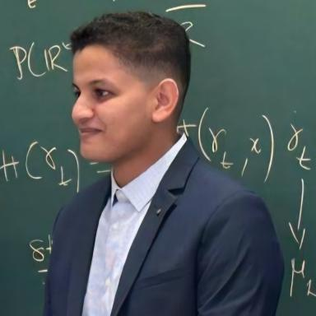 Mohamed, Alfaki ABOUBACRINE ASSADEK Docteur (PhD) en Mathématiques : Analyse et Probabilités

Identifiants chercheurs

- IdHAL : magaboubacrine
- ORCID : 0000-0002-3281-1954

Présentation

The main goal of my research field is the study of the long-time behavior of nonlinear dynamics of the McKean-Vlasov type. More precisely, on the one hand, among others, I am interested in mean-field Langevin dynamics: limit by propagation of chaos of systems of Langevin particles in mean-field interaction. I study the different characterizations of invariant probability distributions and the exponential convergences of the laws of these processes towards equilibrium. On the other hand, my interest is focused on McKean-Vlasov processes absorbed at the boundary of a regular bounded domain: study of quasi-stationary distributions, their different characterizations, the convergences of occupation measures towards quasi-equilibrium.

Publications

Pré-publication, Document de travail (2)

Exponential ergodicity of mean-field Langevin dynamics by synchronous coupling
Mohamed Alfaki Aboubacrine Assadek
2025
Pré-publication, Document de travail
hal-05236513v1
On the exponential ergodicity of the McKean-Vlasov SDE depending on a polynomial interaction
Mohamed Alfaki Ag Aboubacrine Assadeck
2024
Pré-publication, Document de travail
hal-04110753v5

