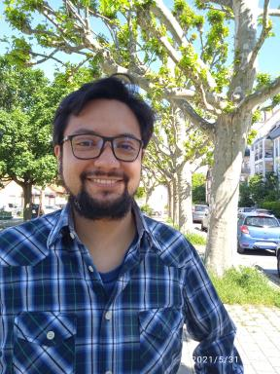 Marco Guevara PhD at LIVE - Laboratoire Image Ville Environnement

Identifiants chercheurs

- IdHAL : maguevaral

Présentation

Engineer with more than ten years of experience in modeling and simulation in the industrial and scientific sectors. High level of programming in several languages, knowledge of various simulation programs and techniques. Very comfortable with new technologies and teamwork. Determined, conscientious and meticulous in his tasks. High availability and proven versatility in its field of expertise.

Publications

Article dans une revue (1)

Implementation and evaluation of WRF simulation over a city with complex terrain using Alos-Palsar 0.4 s topography
Marco Andrés Guevara Luna,Alejandro Casallas,Luis Carlos Belalcázar Cerón,Alain Clappier
Environmental Science and Pollution Research, 2020, 27 (30), pp.37818-37838. ⟨10.1007/s11356-020-09824-8⟩
Article dans une revue
hal-03008770v1

