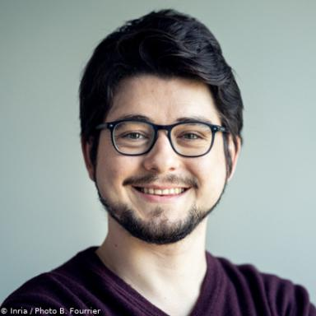 Marc JOURDAN

Identifiants chercheurs

- IdHAL : marc-jourdan
- ORCID : 0000-0002-2449-4549
- arXiv : jourdan_m_1
- cv.identifier.google scholar : BOXGjhgAAAAJ

Publications

Communication dans un congrès (9)

Best-Arm Identification in Unimodal Bandits
Riccardo Poiani,Marc Jourdan,Emilie Kaufmann,Rémy Degenne
AISTATS 2025 - 28th International Conference on Artificial Intelligence and Statistics, May 2025, Phuket, Thailand
Communication dans un congrès
hal-05125233v1
Pareto Set Identification With Posterior Sampling
Cyrille Kone,Marc Jourdan,Emilie Kaufmann
AISTATS 2025 - 28th International Conference on Artificial In- telligence and Statistic, May 2025, Phuket, Thailand
Communication dans un congrès
hal-05125257v1
Optimal Best Arm Identification under Differential Privacy
Marc Jourdan,Achraf Azize
NeurIPS 2025 - 39thh Annual Conference on Neural Information Processing Systems, Dec 2025, San Diego, United States
Communication dans un congrès
hal-05393608v1
On the Complexity of Differentially Private Best-Arm Identification with Fixed Confidence
Achraf Azize,Marc Jourdan,Aymen Al Marjani,Debabrota Basu
NeurIPS 2023 – Conference on Neural Information Processing Systems, Dec 2023, New Orleans (US), United States. pp.71150--71194
Communication dans un congrès
hal-04215474v1
Dealing with Unknown Variances in Best-Arm Identification
Marc Jourdan,Rémy Degenne,Emilie Kaufmann
Algorithmic Learning Theory (ALT), Feb 2023, Singapore (SG), Singapore
Communication dans un congrès
hal-04306221v1
Non-Asymptotic Analysis of a UCB-based Top Two Algorithm
Marc Jourdan,Rémy Degenne
Thirty-seventh Conference on Neural Information Processing Systems, Dec 2023, New Orleans (Louisiana), United States
Communication dans un congrès
hal-03830958v1
An ε-Best-Arm Identification Algorithm for Fixed-Confidence and Beyond
Marc Jourdan,Rémy Degenne,Emilie Kaufmann
Advances in Neural Information Processing Systems (NeurIPS), Dec 2023, New Orleans, United States
Communication dans un congrès
hal-04306214v1
Choosing Answers in epsilon-Best-Answer Identification for Linear Bandits
Rémy Degenne,Marc Jourdan
39th International Conference on Machine Learning (ICML 2022), Jul 2022, Baltimore, United States
Communication dans un congrès
hal-03830700v1
Top Two Algorithms Revisited
Marc Jourdan,Rémy Degenne,Dorian Baudry,Rianne de Heide,Emilie Kaufmann
NeurIPS 2022 - 36th Conference on Neural Information Processing System, Nov 2022, New Orleans, United States
Communication dans un congrès
hal-03825103v1

Pré-publication, Document de travail (2)

Differentially Private Best-Arm Identification
Achraf Azize,Marc Jourdan,Aymen Al Marjani,Debabrota Basu
2024
Pré-publication, Document de travail
hal-04615690v1
An Anytime Algorithm for Good Arm Identification
Marc Jourdan,Clémence Réda
2024
Pré-publication, Document de travail
hal-04688141v1

