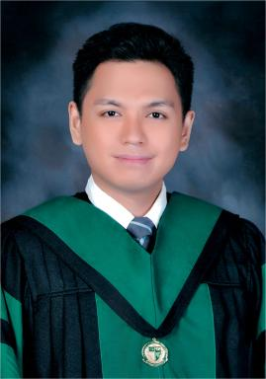 Marc Kenneth Cabañero Certified Family Physician (CFP) of the Philippine Academy of Family Physicians (PAFP)

Identifiants chercheurs

- IdHAL : marc-kenneth-cabanero
- ResearcherID : MYR-2666-2025

Publications

