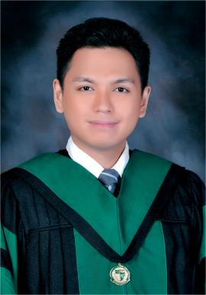 Marc Kenneth Cabañero Certified Family Physician (CFP) of the Philippine Academy of Family Physicians (PAFP)

Identifiants chercheurs

- IdHAL :
marc-kenneth-cabanero
- ResearcherID :
MYR-2666-2025

Publications

