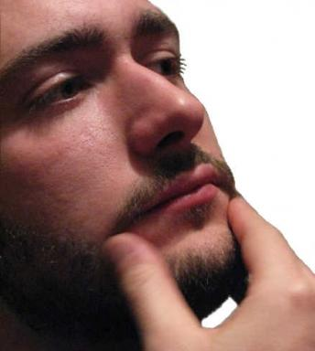 Marco Solieri

Identifiants chercheurs

- IdHAL :
marco-solieri
- ORCID :
0000-0003-4531-2633

Présentation

Publications

Article dans une revue (2)

Geometry of resource interaction and Taylor–Ehrhard–Regnier expansion: a minimalist approach
Marco Solieri
Mathematical Structures in Computer Science, 2016, pp.1 - 43. ⟨10.1017/S0960129516000311⟩
Article dans une revue
hal-01400359v1
Geometry of Resource Interaction - A Minimalist Approach
Marco Solieri
Electronic Proceedings in Theoretical Computer Science, 2015, Proceedings Third International Workshop on Linearity - Vienna, Austria, 13th July, 2014, 176, pp.79-94. ⟨10.4204/EPTCS.176.7⟩
Article dans une revue
hal-01091754v2

Communication dans un congrès (1)

Is the Optimal Implementation Inefficient? Elementarily Not
Stefano Guerrini,Marco Solieri
2nd International Conference on Formal Structures for Computation and Deduction (FSCD 2017), Sep 2017, Oxford, United Kingdom. pp.17:1 - 17:16, ⟨10.4230/LIPIcs.FSCD.2017.17⟩
Communication dans un congrès
hal-01644123v1

Thèse (1)

Sharing, Superposition and Expansion: Geometrical Studies on the Semantics and Implementation of λ-calculi and Proof-nets
Marco Solieri
Logic in Computer Science [cs.LO]. Université Paris XIII, Sorbonne Paris Cité; Università di Bologna, 2016. English. ⟨NNT : ⟩
Thèse
tel-01400369v1

