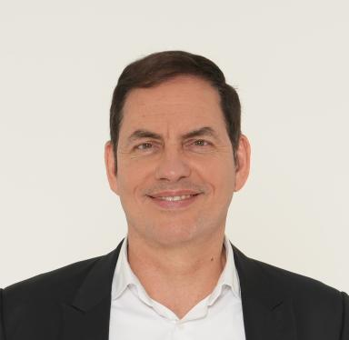 Marek Jenöffy

Présentation

Dr. Marek Jenoeffy received his doctorate from Humboldt University Berlin in 1997. After a career in the financial services industry that led him to Switzerland and the USA, and working as a sales coach, he opened a boutique wealth management firm in Düsseldorf. He is currently director of Büro am Carlsplatz, and member of the supervisory board of F&P Executive Solutions AG, a consulting firm. He presented several papers on conferences in the United States over the past decade.

Publications

Pré-publication, Document de travail (4)

Can the Seesaw Model Depict the Certainty Effect?
Marek Jenöffy
2023
Pré-publication, Document de travail
hal-04136569v1
The Impact of a Photo on Decisions
Marek Jenöffy-Lochau
2023
Pré-publication, Document de travail
hal-04136560v1
Preference Formation and Economic Theory
Marek Jenöffy-Lochau
2023
Pré-publication, Document de travail
hal-04139498v2
A Seesaw Model of Choices
Marek Jenöffy
2023
Pré-publication, Document de travail
hal-04136550v1

Communication dans un congrès (4)

How to Shape Preferences? Testing a Simple Economic Model of Endogenous Preferences
Marek Jenöffy-Lochau
45th Annual EEA Conference, Eastern Economic Association, Feb 2019, New York, United States
Communication dans un congrès
hal-04139360v1
The Origin of Preferences, Economic Decision Theory, and Yaari
Marek Jenöffy-Lochau
40th Annual EEA Conference, Eastern Economic Association, Mar 2014, Boston (MA), United States
Communication dans un congrès
hal-04139624v1
Information, Credibility, and Endogenous Preferences
Marek Jenöffy-Lochau
39th Annual EEA Conference, Eastern Economic Association, May 2013, New York, N.Y., United States
Communication dans un congrès
hal-04139636v1
On the Origin of Preferences
Marek Jenöffy-Lochau
Southern Economic Association, Southern Economic Association Annual Conference, Nov 2012, New Orleans (LA), United States
Communication dans un congrès
hal-04139344v1

