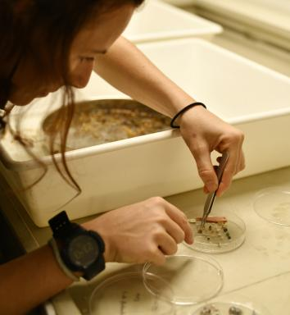 Margot Thibault

Identifiants chercheurs

- IdHAL : margot-thibault
- ORCID : 0009-0009-3991-1323
- IdRef : 277612810

Présentation

Margot is conducting research on plastic pollution in the South-West Indian Ocean. She investigates pollution on the ocean surface, on remote islands, and through ingestion by bio-indicator species. Her methods include manta trawling, visual surveys, long-term monitoring, and polymer identification using ATR-FTIR spectroscopy.

Publications

Article dans une revue (5)

Marine plastic debris as a reservoir and vector of antibiotic-resistant pathogens: evidence of transmission to sea turtles in the Southwest Indian Ocean
Philippe Jourand,Alice Philippe,Loris Carret,Shiva Moutoucomarapoule,Celia Crespelet al.
Marine Environmental Research, 2026, 215, pp.107822. ⟨10.1016/j.marenvres.2025.107822⟩
Article dans une revue
hal-05500541v1
Concentration gradient of plastic debris larger than 500 μm detected across the Southwest Indian ocean
Margot Thibault,Adrian Fajeau,Aina Ramanampananjy,Sarah-Jeanne Royer,Gwennaïs Fustemberget al.
Scientific Reports, 2025, 15 (1), pp.22364. ⟨10.1038/s41598-025-02893-0⟩
Article dans une revue
hal-05171978v1
Barau's petrel, Pterodroma baraui, as a bioindicator of plastic pollution in the South-West Indian Ocean: A multifaceted approach
Margot Thibault,Lisa Weiss,Romain Fernandez,Naïs Avargues,Sébastien Jaquemetet al.
Marine Environmental Research, 2024, 202, pp.106709. ⟨10.1016/j.marenvres.2024.106709⟩
Article dans une revue
hal-04705867v1
Microplastics in the insular marine environment of the Southwest Indian Ocean carry a microbiome including antimicrobial resistant (AMR) bacteria: A case study from Reunion Island
Loik Sababadichetty,Guillaume Miltgen,Bryan Vincent,François Guilhaumon,Véronique Lenobleet al.
Marine Pollution Bulletin, 2024, 198, pp.115911. ⟨10.1016/j.marpolbul.2023.115911⟩
Article dans une revue
ird-04348345v1
Do loggerhead sea turtle (Caretta caretta) gut contents reflect the types, colors and sources of plastic pollution in the Southwest Indian Ocean?
Margot Thibault,Ludovic Hoarau,Laurent Lebreton,Matthieu Le Corre,Mathieu Barretet al.
Marine Pollution Bulletin, 2023, 194, pp.115343. ⟨10.1016/j.marpolbul.2023.115343⟩
Article dans une revue
hal-04189719v1

Poster de conférence (1)

Studying plastic debris afloat in the Southwest Indian Ocean using visual surveys, Manta trawling and remote sensing
Margot Thibault,Matthias Egger,Robin de Vries,Julie Gindrey,Laurent Lebretonet al.
7th International Marine Debris Conference, Sep 2022, Busan (Corée), South Korea. Unpublished, 2022, ⟨10.13140/RG.2.2.21108.26240⟩
Poster de conférence
hal-05500643v1

N°spécial de revue/special issue (1)

Plastic pollution: A potential vector of both pathogens and probiotics for corals on the Mascarene Ridge, Indian Ocean
Vyctoria Marillac,Philippe Jourand,Pierre-Louis Stenger,Gwennais Fustemberg,Julie Gindreyet al.
Deep Sea Research Part II: Topical Studies in Oceanography, 224, pp.105556, 2025, ⟨10.1016/j.dsr2.2025.105556⟩
N°spécial de revue/special issue
hal-05500603v1

Thèse (1)

Composition, abundance, origin and distribution of plastic pollution accumulated in the Southern Indian Ocean gyre
Margot Thibault
Biodiversity and Ecology. Université de la Réunion, 2024. English. ⟨NNT : 2024LARE0001⟩
Thèse
tel-05068531v1

