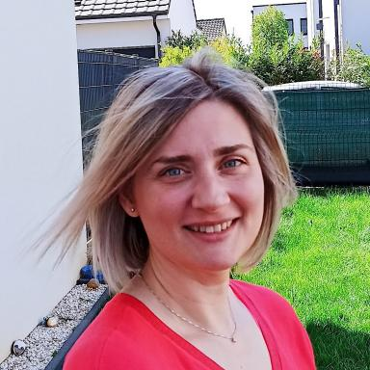 Maria Prokopidou PhD researcher in the field of Artificial Intelligence

Identifiants chercheurs

- IdHAL : maria-prokopidou
- ORCID : 0009-0000-5299-3540

Présentation

Holder of a chemical engineering diploma and a Master's degree in waste treatment, I am capable of analyzing situations, interpreting and transforming information, and adapting to new roles. Throughout my studies and my professional career as a research engineer in two different research centers (AUTh in Greece and LRGP in France), I have developed strong organizational skills that specifically correspond to multitasking environments and prioritizing needs. IT tools and computer software have been an integral part of my studies and my working duties along with tasks related to communication, drafting of scientific and technical reports, organizing and animating project meetings, etc. My international experience and the maturity I have gained during these years, as well as my internal equilibrium between family and career (gained after a long professional pause), have led me to a new adventure as a PhD researcher in the fascinating field of Artificial Intelligence for engineers in LRGP, France; a new journey that I pursue with enthusiasm and motivation!

Publications

Article dans une revue (1)

A Novel Hybrid Modeling Framework for Polymer Reaction Engineering with Application to Real-Time Process Monitoring
Cindy Trinh,Maria Prokopidou,Konstantinos Chatzilygeroudis,Dimitrios Meimaroglou
Industrial and engineering chemistry research, 2025, ⟨10.1021/acs.iecr.5c02499⟩
Article dans une revue
hal-05356779v1

