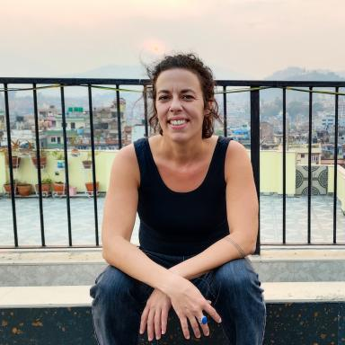 Marie-Caroline Pons ATER – Département des Sciences du Langage, Université Bordeaux Montaigne

Identifiants chercheurs

- IdHAL : marie-caroline-pons
- ORCID : 0000-0001-8850-5510

Présentation

My research focuses on linguistic typology and historical linguistics. I am interested in understanding how language works, varies and evolves, and how it relates to cognition and what it means to be human. Specializing in Trans-Himalayan languages (Tibeto-Burman/Sino-Tibetan) for over a decade, I have been working on the documentation and description of Chepang, Magar, Khamci and Bhoto spoken in Nepal.
Current position at University Bordeaux Montaigne
- Teaching the following linguistic classes : introduction to fieldwork linguistics, language diversity, oral discourse analysis, linguistics of oral
- Creation of courses content for all level (Bachelor-Master)
- Organization of exams, and participation is lab's activities (CLLE UMR 5263)

Publications

Article dans une revue (3)

Marie-Caroline Lyda Pons, The Chepang Language: Phonology, nominal and verbal morphology – synchrony and diachrony of the varieties of the Lothar and Manahari Rivers
Marie-Caroline Lyda Pons
European Bulletin of Himalayan Research, 2022, 59, ⟨10.4000/ebhr.817⟩
Article dans une revue
hal-04634296v1
Review: The Dura language: Grammar and phylogeny
Marie-Caroline Pons
Himalayan Linguistics, 2021, 20 (1), ⟨10.5070/h920155279⟩
Article dans une revue
hal-04634288v1
On the origin of 2nd person prefix # tV - in Trans-Himalayan languages
Marie-Caroline Pons
Linguistics of the Tibeto-Burman Area, 2021, 44 (2), pp.226-263. ⟨10.1075/ltba.20004.pon⟩
Article dans une revue
hal-04634294v1

Thèse (1)

The Chepang language: Phonology, Nominal and Verbal morphology - synchrony and diachrony of the varieties of the Lothar and Manahari Rivers
Marie-Caroline Lyda Pons
Linguistics. University of Oregon, 2022. English. ⟨NNT : ⟩
Thèse
tel-04644030v1

