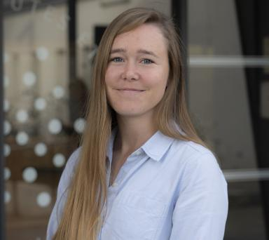 Marie Mainguy Doctorante en épidémiologie

Identifiants chercheurs

- IdHAL : marie-mainguy
- ORCID : 0000-0002-1010-0166

Publications

Article dans une revue (6)

Assessing the Risk of Relapse After In Vitro Fertilization in Women With Multiple Sclerosis
Marie Mainguy,Romain Casey,Sandra Vukusic,Christine Lebrun-Frenay,Eric Bergeret al.
Neurology Neuroimmunology & Neuroinflammation, 2025, 12 (2), pp.e200371. ⟨10.1212/NXI.0000000000200371⟩
Article dans une revue
hal-04947771v1
Prevalence of multiple sclerosis in France in 2021: Data from the French health insurance database
C. Pierret,Marie Mainguy,Emmanuelle Leray
Revue Neurologique, 2024, 180 (5), pp.429-437. ⟨10.1016/j.neurol.2023.12.007⟩
Article dans une revue
hal-04487926v1
Pregnancy-related healthcare utilization among women with multiple sclerosis
Marie Mainguy,Emmanuelle Le Page,Laure Michel,Emmanuelle Leray
Frontiers in Neurology, 2023, 14, ⟨10.3389/fneur.2023.1129117⟩
Article dans une revue
hal-04021750v1
First results of the French OCTOPUS survey among festival attendees: a latent class analysis
Marion Istvan,Vincent Bresdin,Marie Mainguy,Pauline Laigo,Marie Grall-Bronnecet al.
Harm Reduction Journal, 2023, 20 (1), pp.43. ⟨10.1186/s12954-023-00770-5⟩
Article dans une revue
hal-04792710v1
Perception of the Regulatory Change for Zolpidem Prescription by French General Practitioners and Its Relation to Prescription Behavior
Marion Istvan,Benoît Schreck,Marie Mainguy,Pascale Jolliet,Marie Grall-Bronnecet al.
Journal of Clinical Medicine, 2022, 11 (8), pp.2176. ⟨10.3390/jcm11082176⟩
Article dans une revue
hal-03678956v1
Assessing the Risk of Relapse Requiring Corticosteroids After In Vitro Fertilization in Women With Multiple Sclerosis
Marie Mainguy,Hélène Tillaut,Adeline Degremont,Emmanuelle Le Page,Christelle Mainguyet al.
Neurology, 2022, 99 (17), pp.10.1212/WNL.0000000000201027. ⟨10.1212/WNL.0000000000201027⟩
Article dans une revue
hal-03751891v1

Communication dans un congrès (1)

Femmes et hommes atteints de sclérose en plaques : le recours aux soins symptomatiques est-il équitable ?
Marie Mainguy,Emmanuelle Leray,Cécile Donzé
Journées de Neurologie de Langue Française 2026, Association JNLF, Apr 2026, Marseille, France. pp.S131 / P250, ⟨10.1016/j.neurol.2026.02.058⟩
Communication dans un congrès
hal-05577905v1

Poster de conférence (2)

Rehabilitation care for locomotor disorders in multiple sclerosis
Marie Mainguy,Cécile Donze,Emmanuelle Leray
40th Congress of the European-Committee-for-Treatment-and-Research-in-Multiple-Sclerosis (ECTRIMS), Sep 2024, Copenhagen, Denmark. SAGE PUBLICATIONS LTD, Multiple Sclerosis Journal, 30 (3), pp.125 - 680 / P877/2174, 2024, ⟨10.1177/13524585241269219⟩
Poster de conférence
hal-04882250v1
Assessing the risk of relapse after in vitro fertilization in women with multiple sclerosis
Marie Mainguy,Romain Casey,Sandra Vukusic,Emmanuelle Leray,David‐axel Laplaud
9th Joint ECTRIMS-ACTRIMS meeting, Oct 2023, Milan, Italy. SAGE PUBLICATIONS LTD, Multiple Sclerosis Journal, 29 (3), pp.137-393 / P063/1244, 2023, Abstract Book. ⟨10.1177/13524585231196192⟩
Poster de conférence
hal-04415216v1

