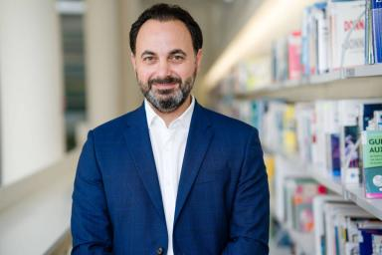 Mark SAMUEL

Identifiants chercheurs

- IdHAL : mark-samuel
- ORCID : 0000-0003-0553-0337

Publications

Thèse (1)

The Non-Linear and Dynamic Socio-Cultural Influences on Perceptual Service Quality in the Middle East Market
Mark Samuel
Humanities and Social Sciences. Grenoble Ecole de Management, 2017. English. ⟨NNT : ⟩
Thèse
tel-04783819v1

