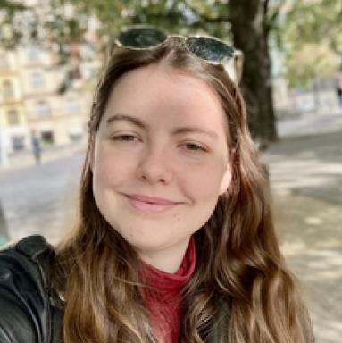 Mathilde Ducos

Identifiants chercheurs

- IdHAL : mathilde-ducos
- ORCID : 0009-0003-4355-1531

Publications

Communication dans un congrès (1)

CoastTerm: A Corpus for Multidisciplinary Term Extraction in Coastal Scientific Literature
Julien Delaunay,Hanh Thi Hong Tran,Carlos-Emiliano González-Gallardo,Georgeta Bordea,Mathilde Ducoset al.
International Conference on Text, Speech, and Dialogue 2024, Sep 2024, Brno (Rép. Tchèque), Czech Republic. pp.97-109, ⟨10.1007/978-3-031-70563-2_8⟩
Communication dans un congrès
hal-04746746v1

