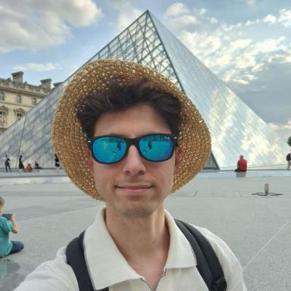 Mattia Garatti Doctorant

Identifiants chercheurs

- IdHAL : mattia-garatti
- ORCID : 0009-0007-0064-063X
- arXiv : garatti_m_1

Présentation

I am a doctoral researcher in Mathematics in the Analyse numérique et équations aux dérivées partielles (ANEDP) team at the Laboratoire de mathématiques d'Orsay, Université Paris-Saclay, Paris (France), under the supervision of Prof. Luca Nenna and Prof. Simona Rota Nodari.
I am a fellow of the MathPhDInFrance program, co-funded by the Marie Skłodowska-Curie Actions (MSCA COFUND), and coordinated by the Fondation Sciences Mathématiques de Paris (FSMP). As a result, I am also affiliated with the EDP et Analyse Numérique team at the Laboratoire Jean Alexandre Dieudonné, Université Côte d'Azur, Nice (France).
I am also a member of the Inria team ParMA (Inria Saclay) and the ANR GOTA.
The macro-set that encompasses most of my research interests is deeply rooted in the Calculus of Variations and the study of variational methods for solving minimization problems.
My Ph.D. research project focuses on regularized optimal transport problems.

Publications

Pré-publication, Document de travail (1)

A PDE approach to Benamou-Brenier formula for the Schrödinger problem
Mattia Garatti,Luca Nenna,Simona Rota Nodari,Luca Tamanini
2026
Pré-publication, Document de travail
hal-05605890v1

