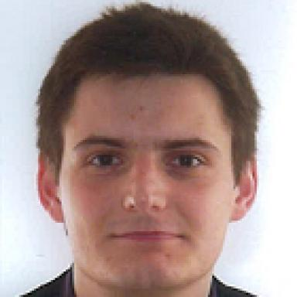 Maxime Rioult

Identifiants chercheurs

- IdHAL : maxime-rioult
- ORCID : 0000-0002-8361-7238
- IdRef : 190792388
- ResearcherID : H-5732-2012

Présentation

I currently hold a post-doctoral beamline scientist position at synchrotron SOLEIL, on the HERMES beamline (soft X-ray spectroscopy and microscopy).
I obtained in september 2015 a PhD degree from Ecole Polytechnique, after 3 years of research activities at the CEA-Saclay (France), in the field of physics and material science for new energies.
My research interests cover physics, materials science, semiconductors, nanotechnology, thin films, synchrotron radiation.

Publications

Thèse (1)

Hematite-based epitaxial thin films as photoanodes for solar water splitting
Maxime Rioult
Physics [physics]. Ecole Polytechnique, 2015. English. ⟨NNT : ⟩
Thèse
tel-01220396v1

