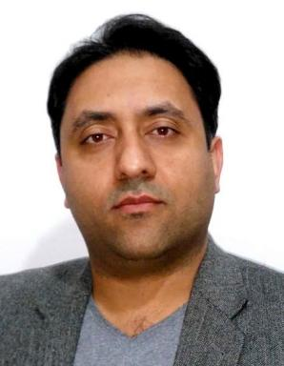 Mazdak Fatahi Research Engineer

Identifiants chercheurs

- IdHAL : mazdak-fatahi
- ORCID : 0000-0001-5881-3555

Présentation

AboutAbout
Member of the neuromorphic team at the University of Lille as an experienced engineer. Experienced in Spiking Neural Network modeling, simulation, and implementing the models on neuromorphic hardware: SpiNNaker and FPGA.Also skilled in Microcontrollers, Embedded systems, IoT, remote monitoring and remote controlling applications.

Publications

Article dans une revue (3)

ModNEF : An Open Source Modular Neuromorphic Emulator for FPGA for Low-Power In-Edge Artificial Intelligence
Aurélie Saulquin,Mazdak Fatahi,Pierre Boulet,Samy Meftali
ACM Transactions on Architecture and Code Optimization, 2025, ⟨10.1145/3730581⟩
Article dans une revue
hal-05033844v1
Event-driven nearshore and shoreline coastline detection on SpiNNaker neuromorphic hardware
Mazdak Fatahi,Pierre Boulet,Giulia D’angelo
Neuromorphic Computing and Engineering, 2024, 4 (3), pp.034012. ⟨10.1088/2634-4386/ad76d5⟩
Article dans une revue
hal-04699880v1
Rate-coded DBN: An online strategy for spike-based deep belief networks
Mazdak Fatahi,Mahyar Shahsavari,Mahmood Ahmadi,Arash Ahmadi,Pierre Bouletet al.
Biologically Inspired Cognitive Architectures, 2018, 24, pp.59 - 69. ⟨10.1016/j.bica.2018.04.009⟩
Article dans une revue
hal-01808815v1

Communication dans un congrès (2)

Towards an Spiking Deep Belief Network for Face Recognition Application
Mazdak Fatahi,Mahmood Ahmadi,Arash Ahmadi,Mahyar Shahsavari,Philippe Devienne
6th International Conference on Computer and Knowledge Engineering (ICCKE 2016), Oct 2016, Mashhad Iran
Communication dans un congrès
hal-01382624v1
evt_MNIST: A spike based version of traditional MNIST an event-based MNIST
Mazdak Fatahi,Mahyar Shahsavari,Mahmood Ahmadi,Arash Ahmadi,Philippe Devienne
1st International Conference on New Research Achievements in Electrical and Computer Engineering, May 2016, Teheran, Iran
Communication dans un congrès
hal-01382631v1

Logiciel (1)

ModNEF : MODular Neuromorphic Emulator for Fpga
Aurélie Saulquin,Mazdak Fatahi,Pierre Boulet,Samy Meftali
2026, ⟨swh:1:dir:abc8c762e0ef9fdb7241ee66670c9783f3122c3f;origin=https://gitlab.univ-lille.fr/bioinsp/ModNEF;visit=swh:1:snp:896c4ea374fc052f6742bcfd6e26b27e3dc59277;anchor=swh:1:rev:3e6dad9a460719607b5514a44de879466f703de6⟩
Logiciel
hal-05545253v1

