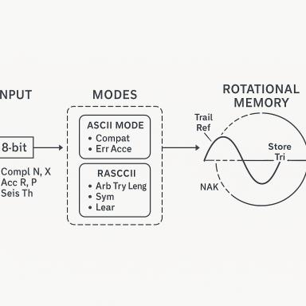 Meriem Adjailia

Publications

Pré-publication, Document de travail (1)

Rex-K3L v2 (2025): Perceptual Projection for Instant Inference from Flat Binary Inputs
Abdelkrim Fellouri,Meriem Meriem Adjailia
2025
Pré-publication, Document de travail
hal-05222939v1

Article dans une revue (3)

A Novel Trit-Based Logic Model for Signal Processing and Memory Systems
Adjailia Meriem,Fellouri Abedelkrim
International Journal of Scientific Research and Management, In press, 13 (06), pp.2276-2278. ⟨10.18535/ijsrm/v13i06.ec06⟩
Article dans une revue
hal-05123570v1
Transcending the Forbidden through Executable Ternary Logic: A Formal Experimental Study
Abdelkrim Fellouri,Meriem Adjailia
International Journal of Scientific Research and Management, In press, 13 (08), pp.2457-2480. ⟨10.18535/ijsrm/v13i08.ec01⟩
Article dans une revue
hal-05200640v1
REX–K3L: A Novel Approach for Neuromimetic and Contextual Machine Logic
Abdelkrim Fellouri,Meriem Adjailia
International Journal of Scientific Research and Management, 2025, 13, pp.2406 - 2423. ⟨10.18535/ijsrm/v13i07.ec04⟩
Article dans une revue
hal-05187186v1

