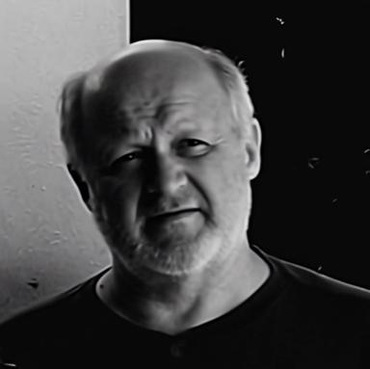 Michael Tikhomirov Director of Scientific-Production Company &quot;SENS&quot; Ltd, Kharkov (SPC &quot;SENS&quot; Ltd), Ukraine.

Publications

