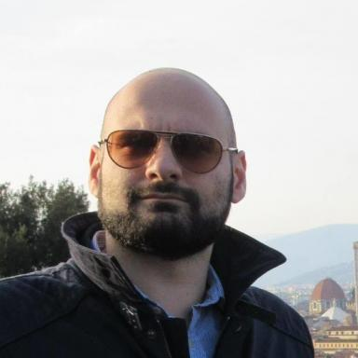 michele tirico Postodoctoral researcher at Licit-Eco7 lab (Univ Lyon, ENTPE, Lyon)

Présentation

Publications

Article dans une revue (2)

Multi-scale comparison of modeling chains for traffic-related air pollutant emission assessment
Michele Tirico,Valentin Le Bescond,Delphine Sengelin,Pascal Gastineau,Arnaud Can
Sustainable Cities and Society, 2025, 129, pp.106354. ⟨10.1016/j.scs.2025.106354⟩
Article dans une revue
hal-05305911v1
Modeling traffic-related air and noise pollution: Multi-criteria assessment case study around schools
Michele Tirico,Yu Gao,Delphine Sengelin,Pascal Gastineau,Pierre Aumondet al.
Transportation Research Part D: Transport and Environment, 2025, 149, pp.105029. ⟨10.1016/j.trd.2025.105029⟩
Article dans une revue
hal-05329254v1

Communication dans un congrès (5)

Traffic-Related Human Exposure in Urban Areas: Improving Hotspot Identification
Michele Tirico,Valentin Le Bescond,Pascal Gastineau,P. Volta,Delphine Sengelinet al.
TaP Conference 2025, Nov 2025, Paris, France
Communication dans un congrès
hal-05320176v1
Systemic approach for the assessment of the impact of urban mobility on exposures to environmental Pollutions
Arnaud Can,Pascal Gastineau,Basile Chaix,Delphine Sengelin,Lionel Soulhacet al.
TaP International Conference, Nov 2025, Paris, France
Communication dans un congrès
hal-05320189v1
Traffic-related air pollution and noise exposure in urban area: a multicriteria assessment framework
Michele Tirico,Valentin Le Bescond,Leonardo Galassi Luquezi,P. Volta,Cécile Bécarieet al.
TaP International Conference, Nov 2025, Paris, France
Communication dans un congrès
hal-05320177v1
Assessing pollutant emissions on an urban area using different traffic simulation approaches: multi-agent modelling and microscopic modelling
Michele Tirico,Valentin Le Bescond,Delphine Sengelin,Pascal Gastineau,Arnaud Can
TAP&SE 2023, Sep 2023, Goteborg, Sweden. 5p
Communication dans un congrès
hal-04757919v1
A reaction-diffusion system drives the morphogenesis of spatial complex networks
Michele Tirico,Stefan Balev,Antoine Dutot,Damien Olivier
French Regional Conference on Complex Systems FRCCS 2021, May 2021, Dijon, France
Communication dans un congrès
hal-03357563v1

Chapitre d'ouvrage (2)

Morphogenesis of Complex Networks: A Reaction Diffusion Framework for Spatial Graphs
Michele Tirico,Stefan Balev,Antoine Dutot,Damien Olivier
COMPLEX NETWORKS 2018: Complex Networks and Their Applications VII, pp.769-781, 2019, ⟨10.1007/978-3-030-05411-3_61⟩
Chapitre d'ouvrage
hal-01959369v1
Configurational Approaches to Urban Form: Empirical Test on the City of Nice (France)
Giovanni Fusco,Michele Tirico
SITI - ISMB - DIST. E-agorà for the transition towards resilient communities - INPUT 2016, Conference Proceedings, , pp.376-382, 2016, 978-88-9052-964-1
Chapitre d'ouvrage
hal-01417456v1

